Loading Price Files for United Stationers
and S.P. Richards

Overview of the Process to Load Price Files
Below are the basic steps needed to complete the entire process of creating and updating the wholesaler product and price information to your system. A separate document describes how to create contracts from the wholesaler data.

Note: You can perform steps 2 and 3 before, during, or after step 1.

- Load wholesaler data from the web, e-mail, CD, or other format. (Instructions are contained in this document.)

- If the vendors have not already been added to your system, create the vendors using Vendor Master Maintenance (menu-12.4.1). An important field for the product update is the Nonstk whses field on the first screen of the Vendor Master Maintenance. If you use the vendors that we sent with the software, this field has been filled in with warehouse 001.

- Set up the parameters for the price file updates. You can access the parameter maintenances on the Wholesaler Update Setup menu (menu-21.1.1). Wholesaler Parameter Maintenance (menu-21.1.1.2) and Vendor Wholesaler Parameter Maintenance (menu-21.1.1.3) are the ones that require the most work. If you want to cross-reference the product classes differently, then use Wholesaler Product Class Xref (menu-21.1.1.5). This is documented in the Wholesaler Maintenance manual. To set up the price plans and catalog codes, use screen 2 of Vendor Wholesaler Parameter Maintenance (menu-21.1.1.3.F2):
  - For the United update, the catalog code and price plans are needed.
  - For the SPR update, the catalog code is always 0001, and price plans are needed.
  - Daisytek data is no longer available.
  - For the PPI update, price plans and catalog codes are not needed.
  - As for Azerty, did you need an Azerty vendor number on the product? In other words, do you need to create separate POs for Azerty?

- Once you have finished steps 1 through 3, run the price file update to create products. They should be run in order of how you normally purchase. Each should be run separately. There is a sleep timer on each one. The updates usually take about 1 to 1 ½ hours. There should be no one else on the system doing anything with products (order entry, maintenance, etc) during the updates.

- When you are done performing all of the price file updates, you need to run the
Wholesaler Vendor Rearrange & Prod Xref Rebuild option (menu-21.1.13). This option updates cross-references and resequences your products. The resequence process places your primary vendor first on the product for the cost used in order entry for pricing. The products may get out of sequence if your secondary vendor added the product before your primary one did. This sequence does not control the purchasing cycle. This process takes about an hour or two.

Note: If you do not want to resequence, then you can skip the Wholesaler Vendor Rearrange & Prod Xref Rebuild option and instead run the Complete Rebuild option (menu-12.3.10.4), which rebuilds your cross-references.

The remainder of this document details the steps needed to load the wholesaler product and price data onto your system.

Loading United Price Files
You generally should receive the United CD about 30 days prior to the start of the next quarter. The file on the CD is not the only file that needs to be loaded. There may be additional price plans to load; these price plans can change from one quarter to the next and can be found on the Internet.

- To download your price plans, you need to log on to www.ussco.com, United’s web site. You must know your client name and password to log on; if you have more than one account, you also must you’re your account number. The price plans are not loaded on this site until the 20th of the month prior to the new quarter.

- Once you log on to the web site, you need to click Price File Download. This brings you to the screen that allows you to select the price plans to download. An example of this is below:

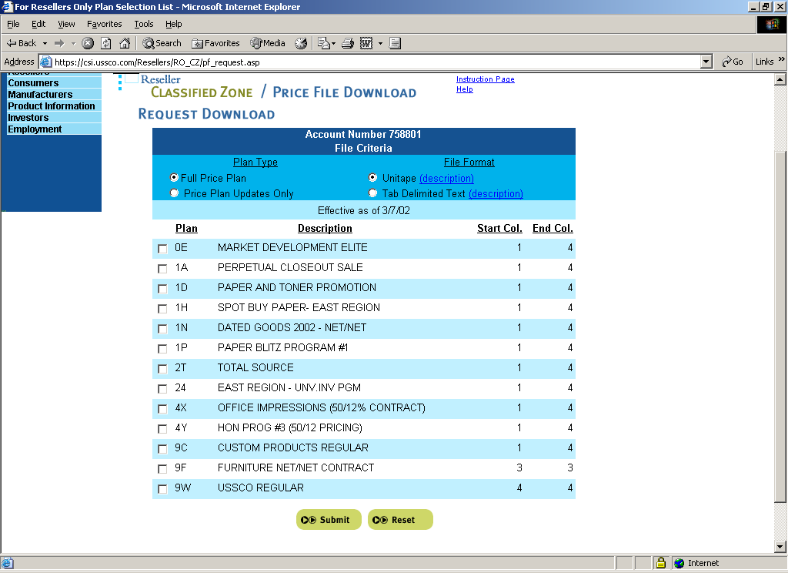

- Select all of the available price plans to download that are not on the United CD. The list of price plans is included in the Unitape HI-LITE document. Once you have selected all the price plans you want, then click the Submit button. You will not be able to download the file as soon as you make your selections because the system needs to create the file for you; this takes about 10 minutes. So you will need to log off of the web site at this point.

- Create a folder on your PC called update, and place it on the root directory of your PC: C:\update. This will be the location where you will save all of the United files.

- When you go back to the site, log on like you did the first time and select the Price File Download option again. An example of what the screen should look like is below.

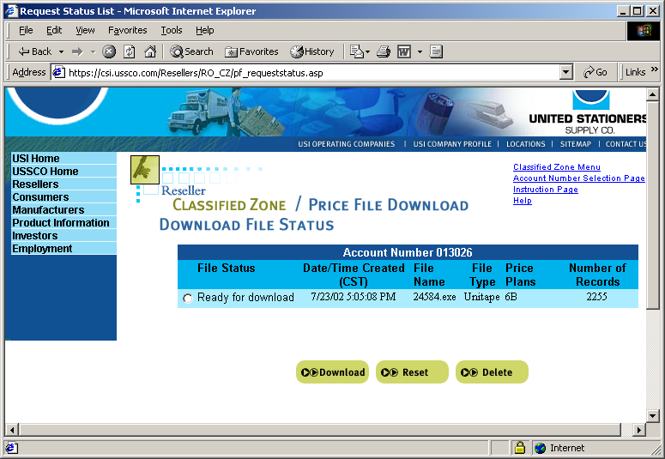

- Select the Ready for download option and click the Download button.

- Once the file is downloaded, place it in your C:\update folder. Each of the files that are downloaded from United’s web site has a file name with some numbers; an example is 17143.exe. Double-click each file to run it; this creates a text file in that directory with the same name.

- Copy the file from the United CD to the C:\update folder. Using Windows Explorer, you can move the unitape.01 file to your C:\update folder on your PC, as well as any confidential price plans that you may receive via e-mail from United. Make sure to uncompress any files that were received from United before continuing.

Steps 9 and 10 explain how to combine the files into one file so that you can run the conversion on your system.

- On the Start menu of your PC, select Run. The Run dialog box appears.

- In the Open field, type cmd. A new window appears. Following are guidelines for combining your files.

  - Change the directory to your update folder. If your update folder is at the root level of your hard drive, type cd update. If the update folder is a different location, type cd \update.
  - To view the contents of the directory, type dir/p.
  - To combine all of the files, use the following DOS copy command: copy filename+filename+filename newfilename
Make sure you use the .TXT files, not the .EXE files, when running this command.

Examples of these steps are shown in the screen shot below.

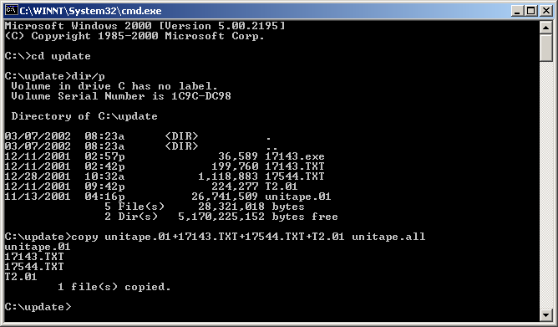

A file called unitape.all has now been created; it contains all of the records that need to be loaded for United.

- Log on to your Vision system.

- Select the Convert United CD to File - UNITED_HOLD option (menu-21.1.2.1C).

- When you are prompted for a password, enter the following: TSH

- Type RUN to begin the load.

- The system prompts you with the following options: (C)lear or (A)ppend the United_Hold file. Select Clear if you are loading a new quarter. Only select Append if you are adding additional price plans to the hold file.

- Type the path of the file that you are loading: C:\update\unitape.all

- Type T to transfer the files.

- Follow the on-screen instructions to complete the installation. You will be asked for a UNIX password; use the same password that you used to log on to the system.

- Once the FTP window disappears, press Y to finish the load. The system displays a counter as it loads the files on your system. When the load is complete, the system will prompt you what to do.
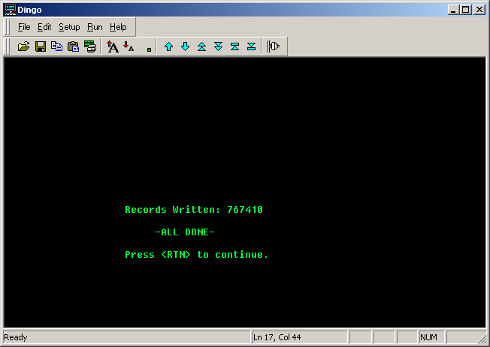

Loading S.P. Richards Price Files
The steps for loading the SPR data are similar to the ones described for loading the United data.

- Copy the following files from the SPR CD to your C:\update folder:
  - EnhComplete: This is the complete master file.
  - EnhStandardContracts: This file contains is standard contracts.
  - EnhCustomContracts: This file contains is custom contracts.
  - EnhUpdate: This file contains updates.
Using Windows Explorer, you can copy these files to your C:\update folder on your PC. Also copy any special price plans that you may have received from SPR.

- Combine the files into one file called spr.all using the method described for United in steps 9 and 10 of this document.

Once the files have been merged into one large file, you may now load it on your system:

- Log on to your Vision system.

- Select the Convert SP.Richards CD or Email File - SPR_HOLD option (menu-21.1.3.1C).

- When you are prompted for a password, enter the following: TSH

- Type RUN to begin the load.

- The system prompts you with the following options: (C)lear or (A)ppend the United_Hold file. Select Clear if you are loading a new quarter. Only select Append if you are adding additional price plans to the hold file.

- Type the path of the file that you are loading: C:\update\spr.all

- Type T to transfer the files.

- Follow the on-screen instructions to complete the installation. You will be asked for a UNIX password; use the same password that you used to log on to the system.

- Once the FTP window disappears, press Y to finish the load. The system displays a counter as it loads the files on your system. When the load is complete, the system will prompt you what to do.

