Customer Service & CRM Enhancements
New Customer dialog notes on profile form
New Attach a profile icon to customer class
New 8 additional profile icons and a pipeline report
New Customer monthly sales target field
Default order source for quick order entry
Quick keyboard navigation
Wild card part / product search

Accounting Enhancements
New Graphical A/R drill-downs
New Flexible rules-based G/L account configuration
Spread payments automatically across multiple companies in recurring voucher entry
Daily, weekly, and monthly customer aging
Automatically fax, print, or e-mail customer statements at EOD, EOW or EOM
New Fax, print, or e-mail customer statements on demand
New Customer core statements

Inventory Management Enhancements
New MyCode – flexible category used in pricing and replenishment
New Past Inventory Valuation report
New Fee-based warehouse management

Tools and Utilities
New Server-to-PC and PC-to-Server file transfer tool

Miscellaneous Improvements

THE SYSTEMS HOUSE
Vision – Release 6.3
3rd Quarter 2004
Introduction

Vision Release 6.3 offers some great new accounting and customer management tools. A new GUI Accounts Receivable tab supports graphical drill-down into A/R aging buckets and payment details; supports daily/weekly/monthly customer aging views and statements that can be printed, faxed, or e-mailed automatically or on-demand. In addition, a new rules-based general ledger tool lets you easily define how exceptional general ledger postings should occur.

Vision 6.3 CRM lets you add a visual customer target A-B-C-D ranking icon to each customer class which displays alongside the customer’s current profile icon to give your sales and service reps another quick way to instantly identify the customer’s activity goal and corresponding service level. Four new arrow icons and a pipeline status report have been added to improve sales prospecting visibility. A new sales target field has been added to customer maintenance to store a monthly target sales goal for each account. CRM Notes entered on the home page now display on the customer profile form in addition to posting into the customer history so critical ongoing customer dialog is immediately visible to everyone in your enterprise right after a customer lookup.

Keyboard-only navigation options have expanded on the Customer Service tab to support ultra-quick entry of large stock orders and improved motion control for users who prefer a keyboard over mouse.

In Product Maintenance the Miscellaneous code field has been renamed “My Code” and you can now use this self-defined category field to drive your price level pricing and replenishment rules. A new fee warehouse type has been added to warehouse maintenance, giving you the ability to pick and process orders for vendor-owned inventory seamlessly alongside your own inventory. Sales of vendor-owned products are recapped in a daily report back to the vendor and proper G/L transactions are booked for the sale of vendor-owned items.

The best business practice concepts and tools delivered within Vision 6.3 represent one facet of the ongoing commitment that The Systems House continues to make to ensure that our customers always maintain a leader’s competitive edge.

Copyright © 2004 The Systems House, Inc. All rights reserved
The Systems House, The Systems House logo, Vision, TSH Vision, and Vision Supply Point are either registered trademarks or trademarks of The Systems House, Inc. in the United States and other countries.
Protobase is either a trademark or a registered trademark of Southern Data Communications, Inc.
Vendere and Thalerus are either trademarks or registered trademarks of Thalerus, Inc.
IBM and AIX are registered trademarks of IBM in the United States.
Linux is a registered trademark of Linus Torvalds.
Microsoft, Windows, and Business Solutions Great Plains are either registered trademarks or trademarks of Microsoft Corporation in the United States and/or other countries.
All other trademarks and registered trademarks are property of their respective owners.

Customer Service & CRM Enhancements

New Customer dialog notes on profile form

The Customer Profile form now displays two types of customer notes – static notes that are not time-sensitive and apply generally to a customer account and dynamic notes that are situational and surface in ongoing dialog with a customer. Keeping relevant customer dialog visible to everyone in your organization is a best-business-practice that can help you provide top-quality customer service. This practice is commonly called “customer transparency” in CRM jargon.

Static customer account notes are entered on the Customer Maintenance form and have always been displayed following a customer search on the Customer Profile form.
These notes are used to share information about an account that applies to all orders or to the customer in general. Examples of good use might include: “Susie is very bad about placing multiple orders – check order history first!”, “This customer is a branch of XYZ company so be extra courteous – we’re fighting for the XYZ business!”, “This company is owned by our CFO’s wife”. These notes are best used for sharing general, non-time-sensitive information.

Dynamic notes are entered on the home page follow-up form and give you a way to share the ongoing dialog between your customers and everyone in your organization.

When the CRM “Info” event is set to “Update customer file” or if the route-to customer file option is checked on the Home Page follow-up form, these dynamic dialog notes display (along with orders and invoices and other account activity) on the Customer History form. Now, in addition to updating the customer history, these dialog notes also display on the Customer Profile form alongside the static customer notes under the new heading, “Recent CRM Notes”.

Two notes buttons now show on the Customer Profile form. Clicking on “Recent CRM Notes” brings the dynamic dialog notes into focus and clicking on the “Customer Notes” brings the static customer account notes into focus.

When the Customer Profile form first displays, the default view will be whichever type of note exists for the account. If an account has both types of note, the Recent CRM Notes will be displayed on top. If either type of note exists, a graphic note indicator will display next to the button label to alert you that more notes exist.

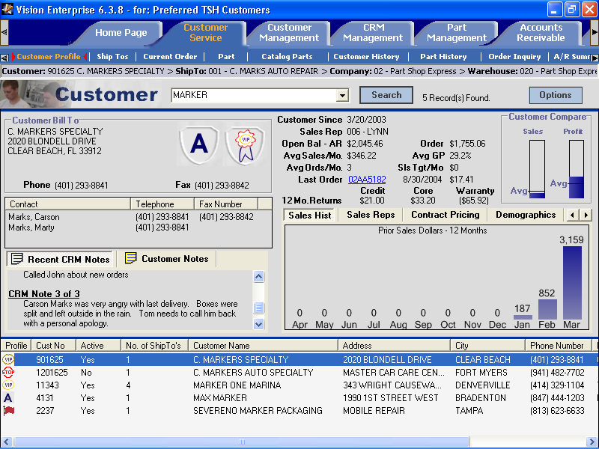

New Attach a Customer Profile Icon to customer class

CRM profile icons can now be attached to customer classes in addition to being attached to an individual customer. Two visual icons can now be displayed for each customer account on the Customer Profile form – one for the customer class and one for the individual customer. This new option lets you assign a visual icon with less maintenance effort than if you choose to implement profile icons at the customer level. And it can offer an additional visual cue if you choose to use icons at both the class and customer levels. The same set of profile icons is available at the customer profile and customer class level for maximum flexibility.

Profile icons can be added to the customer class on the Customer Class form on the Vision Configuration tab. Profile icons can be added to the customer account on the Customer Maintenance tab > Main form. Note that some fields have been reorganized on this form to provide more room for entry, separating company information and classification information in the lower left portion of the screen. A new Classifications button has been added and the Customer Profile indicator is now maintained on this new panel.

New 8 additional profile icons and a pipeline report

8 new graphic profile icons have been added including A, B, C, D, 25%, 50%, 75% and 100% arrow icons.



Both red and blue A,B,C,D icons now exist so that you can assign a target volume goal for the account at the customer class level, and then assign a current volume icon for the customer. For example, you might assign the blue “A” to your largest customers by attaching the icon to the “large account” class in customer class maintenance. Then for every customer in your “large account” class you might assign the red “A” if the customer was performing up to your definition of large account volume, or a red “B” or “C” if the customer had the potential to be a large account but was currently not producing that level of business. The visual indicators of blue “A” and red “C” can tell your sales and service representatives at a glance that the account has more potential business than you are currently realizing.



Four arrow icons (25%, 50%, 75%, and 100%) have also been added. These can be used to identify a pre-sale prospect who is in your pipeline prior to their placing a first order. When a sales prospect is entered on the Customer Maintenance > Main form, choose the arrow which best corresponds to their forecasting certainty or their stage in your pipeline. As time passes the prospect moves through your pre-sale steps and the opportunity becomes more certain, the sales associate who manages the account can reset the profile icon to best represent the new likelihood of the deal. As they work appointments and follow-up activities with these prospects on their home page, they are recording CRM Info activities which can be recapped back to management in a report.

A new prospect pipeline report has been added to the Sales reports menu. This report selects all open CRM activities for prospects or customers who currently have assigned one of the four CRM profile pipeline arrow categories and recaps the activity detail by salesman by category.

New Customer monthly sales target field

A new monthly sales target field has been added to the Main form > Classifications panel in Customer Maintenance. This field gives you a place to store a monthly sales goal for each account. It can be used in ad hoc reporting to measure actual monthly sales against the target for each account.

Default order source for quick order entry

A new default order source field has been added to Vision Configuration tab > Warehouse folder > Order Processing form. You may choose an existing order source or leave the setting at <none>. If you select an order source other than <none>, all orders placed on the Current Order form for this warehouse will default in the order source you select and initial cursor focus will begin at the line item entry portion of the form. This provides faster order entry speed (by not pausing at order source) when all or most orders entered at a location can be attributed to the same order source.

Quick keyboard navigation

One of the great benefits of a Windows-based graphical user interface is that the user has much more freedom to control how data is entered on a form. Data usually does not need to be keyed in a rigid sequence which more closely matches the environment that people tend to work in. However, behind the scenes this freedom of motion means that the computer has a much harder time figuring out when a keyboard task is ‘done’. To handle this, early Windows applications assigned a special meaning to the ‘Tab’ key, i.e. move to the next entry field or search step. In Windows applications, the ‘Tab’ key typically replaces the functionality of the ‘Enter’ key. Vision has implemented this Windows behavior because it is the standard that users have come to expect in a graphical environment.

A downside of this standard is that the ‘Tab’ key is on the left-side of the keyboard and the numeric 10-key pad is on the right side of the keyboard. For situations which require ultra-fast one-handed 10-key data entry, it is tough to maintain rapid key pace crossing the keyboard to mash the ‘Tab’ key. In Vision, the ‘F12’ function key has now been set to function as a ‘Tab’ key so that one-handed entry can be accomplished without crossing the keyboard in those data entry situations which require rapid 10-key entry.

Cross-form navigation has also been improved throughout Vision, so you can move forward and backward between tabs and forms without using the mouse. A “Ctrl-T” moves forward to the next tab and a “Ctrl-F” moves forward to the next form. A “Shift-Ctrl-T” moves backward to the previous tab and a “Shift-Ctrl-F” moves backward to the previous form. Note that these control sequences do not apply to the Vision BackOffice form.

Hotkey navigation has been added to the Current Order form. Once you have begun entering information on the form, a letter in the description of each control button will display an underline to indicate which ALT- key sequence is setup for the control. Key the ALT-key
sequence to jump focus (hotkey) to the control button. For example, to open
the Order Details form when focus is sitting at line item entry, key “ALT-D”.

Note that the use of hotkeys requires you to be running Windows .NET framework version 1.1 on your client PC. (You can tell which version of the .NET framework you are running by looking at the text version number displayed under the Vision Enterprise logo on the Vision login form.) If you are not running the most recent version of the .NET framework you can load it from Microsoft or from http://vision.tsh.com/.

Wild card part / product search
A partial part or product ID can be entered on the Customer Service tab > Product or Part form and on the Product or Part Maintenance tab > Search form by using the left and right brackets “[“ and “]” as wild cards. Enter a product ID that starts with the left bracket. “[10111” for example, returns all the products on your database that end with “10111”. Enter a product ID that ends with the right bracket. “L10]”, for example, returns all the items in your system that start with “L10” Both wild card brackets can be used in the same search. “[101]” for example, returns all the items in your system that have a “101” somewhere in the product ID. Note that a Product X-Ref rebuild is needed to build the wild-card cross references. This process is run automatically in your end-of-week processing or can be run on-demand from your rebuild menu.

Accounting Enhancements

New Graphical A/R drill-downs
A new Accounts Receivable inquiry tab has been added to Vision giving the ability to more quickly answer customer service questions and assess customer payment patterns. This tab includes an A/R Summary form and an A/R Detail Inquiry form along with a Customer Profile search form which work together to provide a drill down capability into sales, credit, and payment details.
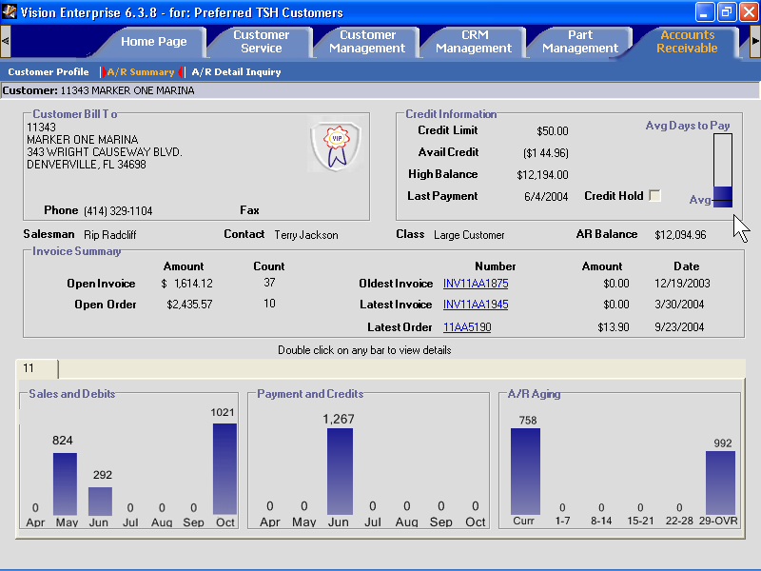
Click here on any bar in the graphs to drill down into transaction details
Clicking on any of the bar graphs on the form will shift focus from the A/R Summary to the A/R Detail Inquiry form showing the transactions which make up the amount shown on the bar graph. Clicking again on any of the transaction lines will display detailed information about the transaction.

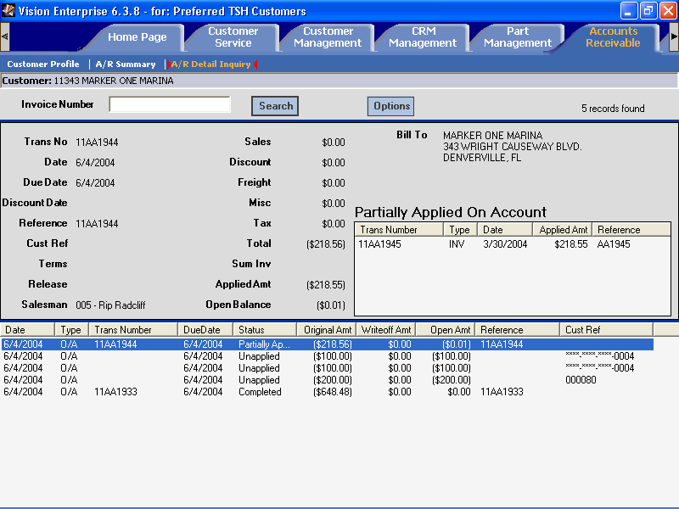
Click on the transaction line to see more detailed info in the top of the form.

A new “Accounts Receivable” role has been added to Vision Security Maintenance. The Accounts Receivable tab will display for users who have been given the Accounts Receivable role.

Average and maximum days to pay thresholds can be set across the system on the Vision Configuration > Dealer Information > Thermometer Settings form.

New flexible rules-based G/L account configuration

A new G/L account configuration tool has been added to the Vision Configuration tab > Dealer Information form to help you more easily manage general ledger account distribution. This new Vision GUI tool replaces the former server-side G/L-PC (Product Class) maintenance. In addition to gathering G/L account definitions in one place, the new G/L maintenance tool allows you to define a set of rules which contain flexible parameters to describe how you update your G/L.

For example, instead of booking the sale of a product into one cost-of-goods sold G/L account, you can define a set of rules which books the sale into more specific accounts based on Company, Warehouse, Product Class (Line), Job code, Salesman, Order Source, Warehouse Type, Bank or Transaction type…or by any combination of these parameters.

By setting up accounts at the product class or order source level, you have the ability to create financial statements which allow detail analysis at the level of granularity that you need.

Spread payments automatically across multiple companies in recurring voucher entry

Recurring Voucher Entry in the Vision back-office now presents a new “distribute” field to let the system automatically spread a regular payable across multiple companies. If you answer “Y” to distribute, you will be prompted to enter a list of companies and corresponding percentages up to 100%.

Daily, weekly, or monthly customer aging

You may be able to improve your cash flow by managing your customer open receivables at a more granular level for slow paying customers. An additional set of aging buckets has been added to Vision and you can now setup a customer account to age and automatically print statements on a daily, weekly, or monthly basis.

On the Customer Maintenance tab > Accounting form you may now indicate that the customer’s statement cycle is daily, weekly, monthly, or never. Aging buckets presented on the new GUI Accounts Receivable tab and reported on the customer statement will now reflect the customer’s configured aging cycle. This does not affect your monthly aged trial balance report, nor your own “corporate” view of your aged receivables, just the customer-facing and customer service-facing views of open A/R.

Automatically fax, print, or e-mail customer statements at EOD, EOW, or EOM

Customer statements can now be setup to print, fax, or e-mail automatically at end-of-day, end-of-week or end-of-month significantly reducing the amount of time you spend on repetitive customer document management.

In conjunction with the daily, weekly, or monthly statement indicator on the Customer Maintenance > Accounting form you can set each customer to receive statements by fax, e-mail or print option. Statements are faxed or e-mailed to the fax number or e-mail address entered on the contacts form for the customer contact individual who is designated as the primary A/R contact. A valid fax or e-mail address must be entered on the Customer Maintenance > Contacts form in order to select the fax or e-mail statement delivery options.

Fax, print, or e-mail customer statements on demand

You can now reprint or re-deliver a customer statement on demand on the Customer Service > Customer Profile form. Just retrieve a customer by their phone number or name and right click on the customer detail line in the lower listview portion of the screen. You are prompted to reprint the statement and/or if the customer is setup to receive a fax or e-mail statement you can choose that statement delivery media.

New Customer core statements

Customers can now be setup to indicate either a loan or a sale transaction for the core value of an item. A core cost and price for an item can be defined on Vision when a product or part has a residual value after the useful life of a product. An example of a core value might be the trade-in value of a battery or the shell of a toner cartridge returned for recycling. When a core item is sold in Vision, Vision keeps track of the sale of the core in a “core bank” for the customer. As core items are returned, Vision decrements the core bank for the item for the customer.

Both sold and loaned cores are tracked individually in each customer’s core bank. A returned core will credit the customer for the core value, if core was originally sold. A returned core will have no monetary impact if the core was originally loaned to the customer.

A customer account can be setup to loan or sell cores by assigning the customer a price level, which indicates how the core should be priced. Customers are assigned a price level on the Customer Management > Pricing form. Price levels on the Pricing > Maintenance Forms folder > Price Level form can indicate that cores are priced based on cost, price, or none (no value). Choosing the ‘none’ option directs Vision to loan cores to the customer.

A new Core Statement field has been added to the Customer Maintenance > Preferences form Document Print group box. When checked, a customer core statement will automatically print following the customer’s A/R statement any time a customer statement is printed.

Inventory Management

New MyCode – flexible category used in pricing and replenishment

The Miscellaneous Code field on the Product or Part Management tab > Main form has been renamed “MyCode” to better describe its use. Miscellaneous Sort Code maintenance on the Vision Configuration tab has been renamed to MyCode maintenance. MyCodes give you a flexible way of defining your own groups of products in addition to the Vision product class and product type categories. All previous miscellaneous code functionality is still supported and any miscellaneous sort codes which are defined will remain intact as MyCodes. Now, however you can use your MyCodes as an additional way to define replenishment rules and price level-based pricing.

For example, perhaps you have an informal “Top 50 products” list of items that cross product class, manufacturer, or ABC code boundaries. They might be your most expensive items or perhaps very small safe-locked items. Or, perhaps you have several families of products which you sell together as a group. You can create MyCodes for each of these groups on the Vision Configuration tab > MyCode maintenance form, then apply each MyCode to the appropriate products in Product Maintenance.

Now on the Purchasing tab > ROP Models form, you have the option to create a replenishment rule using your MyCodes as a factor to select a set of products. Likewise on the Pricing tab > Price Models form, you can use your MyCodes as a product selection factor in your price levels matrix.

New Past Inventory Valuation Report

A new report exists which allows you to report on the value of your inventory at a specific point in time. This report can be useful for strategic business planning purposes to help you correlate sales activity with your inventory investment as it looked at a previous point in time.

The Inventory Valuation Report can be found on the Inventory Reports Menu 8.8.17 for office products dealers and menu 3.2.15 for automotive distributors. This report prompts for as-of-date and can be run selectively for one or all warehouses, product classes, product types, and individual products.

New Fee-based warehouse management

It can be financially attractive for dealers and distributors to provide order fulfillment services for vendor-owned inventory. This is a modified application of the “pay-on-scan” supply chain arrangement which has recently gained attention or been implemented in a variety of distribution markets. Though there are similarities to pay-on-scan in the underlying inventory transaction management, Vision’s Fee Warehouse sub-system differs significantly in its intended use and benefits.

The goal of Vision’s Fee Warehouse is to synergistically benefit both manufacturer and distributor, rather than just shifting inventory costs from distributor to manufacturer. A fulfillment fee warehouse may be a useful business-generating opportunity for the distributor if they have a strong relationship with a manufacturer who wishes to regionally centralize distribution without opening new distribution centers. Or a manufacturer may not have or desire end-customer-facing order processing capabilities so they contract with a distributor or dealer to answer their incoming 800 #, accept their incoming customer orders, and outsource fulfillment by shipping product directly from the distributor’s facility to the manufacturer’s customers.

Manufacturers may find this arrangement attractive because they don’t have to dedicate resources to the fulfillment end of their business for direct customer orders. Distributors may find this attractive as a low sales-effort profit center and because it gives them the opportunity to differentiate themselves from other distributors who are otherwise competing with the same general-line products or parts in the same sales territory. A fee-warehouse relationship with a manufacturer enables the distributor to carry a full line of specialty products without incurring the inventory-carry costs, including those of slower-selling products which would not otherwise be economical for them to fully stock. The fee warehouse approach may be appealing to a specialty manufacturer as an alternative to carrying the same inventory themselves in a region, not as a general business practice for all manufacturers and all their distributors.

Vision now provides the ability to define a logical warehouse inventory as “owned” by a specific vendor (manufacturer) by selecting the vendor on Vision Configuration tab > Warehouse Maintenance > Main form and by entering a fulfillment fee percentage which the distributor will earn on each transaction. Vision order processing has been modified so that when orders are placed for manufacturer owned products, warehouse picking functions occur just like any other product in their own inventory.

A sale of manufacturer-owned products to a distributor customer can be mixed with items from the distributor’s inventory on the same ticket or invoice and is transparent from a material handling point of view, creating a “silent” purchase order/transfer and affecting inventory cost-of-goods sold as would any normal sale. An order from a manufacturer’s customer follows the same material handling flow but does not affect inventory value and does not create a receivable transaction on the distributor’s system for the manufacturer’s customer. Proper G/L is posted, earning commission for the distributor as orders are processed.

A daily activity report runs in EOD recapping orders placed by the manufacturer’s customers for manufacturer-owned items plus separately showing sales of manufacturer-owned products to the distributor (multi-location replenishment) and distributor’s customers (direct demand sales). The recap is faxed, e-mailed, or transmitted to the manufacturer on a daily basis and includes both product and freight costs. The actual sale transaction between the manufacturer and their customers along with invoicing, taxation, and payment collections are completed by the manufacturer based on the daily activity recap.

Vision supports the sale of manufacturer-owned products to both manufacturer customers and distributor customers and multiple manufacturer-owned warehouses can be defined.

Tools and Utilities

New Server-to-PC and PC-to-Server file transfer tool

A new file transfer tool has been added to Vision. Vision File Transfer on the Vision Configuration tab allows you to send a file from your desktop PC to the Vision server, or to retrieve a file from the Vision server and send it to your desktop.

You can move a selected file on demand by entering the file name or choose a Vision standard transfer. Vision standard transfers are pre-existing processes which have been developed to move specific information in a specific fixed format. All file “types” (extensions) can be transferred, although some file types may not be usable when transferred to the server (e.g., “.exe” or executable files).

Access to the Vision file transfer has been added to the following user roles:
- PRODUCT MAINT (GLOBAL)
- SYSTEM ADMIN

- FILE MAINTENANCE ADMIN
- FILE MAINTENANCE WAREHOUSE
- PRODUCT MAINT (WAREHOUSE)

Miscellaneous Improvements

The following miscellaneous enhancements, modifications, and fixes are included in this release:

- The SIC Code and # of Employees fields have been moved from the Customer Maintenance > Accounting form to the Classifications panel on the Customer Maintenance > Main form. This makes the fields accessible to sales users who have been given Sales II role access to enter basic prospect/customer information but not access to pricing and accounting information

- Customer Class maintenance has been moved to GUI. You can add and maintain customer classes on the Vision Configuration tab under the Customer Information folder.

- Miscellaneous Code maintenance has been renamed as MyCode Maintenance on the Vision Configuration tab Product Information folder.

- The A/R Inquiry on the Customer Service tab has been replaced by the A/R Summary inquiry and the A/R Detail Inquiry for consistency of behavior with these new forms on the A/R tab. Drilling down into an A/R transaction on the Customer History form will change focus to the A/R Detail Inquiry. The A/R Summary inquiry will automatically load upon selection of a customer on the Customer Profile form.

- A new CRM ExecutiveSummary event has been added. When activated, this event accumulates sales and cash receipts information and posts the total to the user’s home page. The event can be triggered to run on demand, daily in EOD, or as a scheduled job each hour. If the process is run hourly, hourly totals will accumulate in one follow-up message per each route-to user per each day. If the process is run hourly, a cron job or windows scheduler definition will need to be added to your system. See additional setup notes for more details.

- Independent Stationers contract update was modified to support load of multiple contracts and added to the Vision BackOffice > Pricing update menu.

- Order acknowledgements now retrieve contact name, fax, and e-mail address from the customer ship-to if this data exists, rather than customer contact.

- An automatic startup process has been added to your Vision server which restarts the Vision ConX communication link after a server reboot. In-house systems will no longer need to restart ConX manually after system restart. Vision ConX is the communication tool used to exchange business data between your central Vision server and your user’s desktop PC’s.

- A new job function has been added called "CUSTOMER SERVICE A/R". It is attached to the standard Vision roles of "Customer Service Manager", and "Customer Service Supervisor". Users will need to have one of these roles (or a custom role that contains the new job function) to see the AR inquiry form(s) on the Customer Service tab.

- Now prompting for operator code in manual core transfers and recording it in inventory audit trails

- Receiving report modified to display full product ID for Office Products flavor Vision and short product ID for Automotive

- Vendor item # is now shown on the daily PO Receiving report even for non-primary vendors

- An issue was corrected where in certain circumstances all users were not properly receiving CRM follow-ups when more than one route-to had been indicated on the CRM Management > Event form

- Modified picker print to update the order activity log on the Customer Service tab > Order Inquiry form with operator name rather than initials

- A fourth screen has been added to Company Maintenance in server-side Vision configuration. This screen allows G/L periods to be setup for a new company which are different from those configured at conversion. Users must have operator security access code “FPA” to access this new screen.

- Now printing cash received message on backordered invoices with cash on order

- Modification to requisition list maintenance to allow deletion of ‘main’ requisition and clean-up all associated subordinate lists. If the user tries to delete the ‘main’ requisition record, the system will check for any subordinate requisitions and verify their intent to delete both. If “Y”es is answered, then the ‘main’ and all ‘sub’ requisition records are deleted.

- In Office Products order processing when an item is entered for a wholesaler drop-ship vendor that is not present on the ship route or warehouse bump-down, it will be sent to end-of-line for the user’s review.

- Added sleep time to vendor rearrange process

- Added customer Billing Code description to the Monthly Invoice by Category report

- Added a Commissionable item flag to Vision Configuration tab > Product Information folder > Pricing Class maintenance

- Added contact record conversion to conversion menu. Update inventory audit trail during on-hand conversion.

- Added 2 Unit %’s columns to the Inventory Analysis report to function same as the Sales %’s

- Created a new plain paper version of Vision’s short-form invoice

- Added the ability to cancel transfer pickers from GUI customer service

- Skip updating contract file if an item is flagged as discontinued. Occasionally wholesaler file loads contain updates for discontinued items – they should not be loaded

- ISG File transfer capability incorporated as a “Standard Transfer” in Vision Configuration tab > Vision File Transfer form

- Modified pricing to not consider fixed contracts when the customer attribute “Choose sale over Contract” indicator is set on the Customer Maintenance > Pricing form

- Added an end-of-day option for automated credit card processing

- EOM Customer Month-to-date Sales Listing modified to use company fiscal period rather than invoice date.

- Actual EOM date added to print on MB Department report.

- Removed requirement of a facility code for drop-ship vendors

- Now showing matched count on physical inventory variance report. Items with two matching counts that do not match the freeze quantity will appear on the Variance Report, but will not generate tags for a recount.

- Added Inventory Summary report to End-of-Month

- Modified the Summary Invoice generation process to update the Customer History to show when the AR is now assigned to a summary invoice

- Physical inventory tag creation, now supports an option to prompt only for items whose on-hand is greater than zero.

- Modified United and SPR stock checks to use product numbers based on wholesaler family. Previously when dealer’s product# did not match wholesaler, the stock check was unsuccessful.

- Time and date added to laser invoice and picker prints

- Fax cover sheet is improved on NT systems. The “Send from” field is now the sending user name rather than dealer company name and the send-to company is added.

- Added manufacturer selection option in the Category Month-to-date Sales report. For Automotive added a warehouse totals option

- Improved Customer History rebuild speed by using indexed file keys

- Created a new “2-up” short invoice form

- Added Protobase settings for credit-card handling to the Vision Configuration tab> Dealer Information folder > Dealer Settings form.

