Introduction

Vision Enterprise now allows users to maintain the Average Cost and Core Average Cost fields.

Business Impact

Users must have the ‘Purchasing Manager’ role to be authorized to change the Average costs.
Products average costs can only be maintained from the warehouse level, any warehouse that incurs transfer charges will be restricted from being modified.

Customer Impact

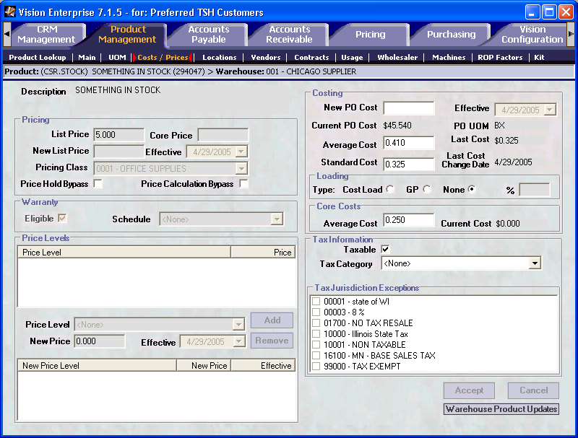

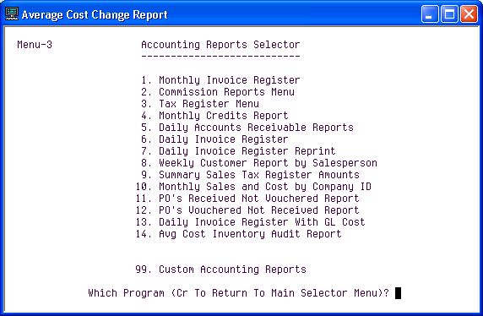

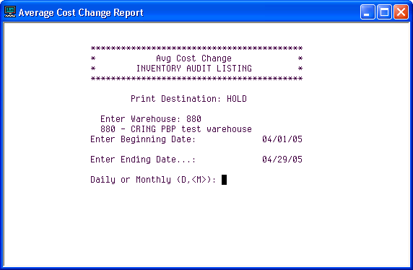

The above selections (Warehouse, Begin/End Dates, Daily or Monthly) will be needed to run the audit report for Average Cost Changes.

A sample report below:
The Authorize will show ‘Avg Cost Chg’ or ‘Core Avg Cost Chg’
The Change description will show the Avg Cost before and after, also the current Core or Cost used for the extended values
The Balance Before is the on hand when the change was done
The Before Extended is the total of the before Core Avg Cost plus the before Avg Cost multiplied by the on hand
The After Extended is the total of the after Core Avg Cost plus the after Avg Cost multiplied by the on hand

06:47:20 04-29-05 Avg Cost I N V E N T O R Y A U D I T L I S T I N G PAGE 1

WHSE EXT.PROD.NO......... DATE.... AUTHORIZE........... Change Description................. BAL.BEF. Before Ext.. After Ext...

001 CSR.STOCK 04/29/05 Avg Cost Chg '0.456' to '0.510' Core '0.123' 489,159 283223.0610 309637.6470
001 CSR.STOCK 04/29/05 Avg Cost Chg '0.510' to '0.410' Core '0.250' 489,159 371760.8400 322844.9400
****
001

2 records listed

