Introduction

There is a new function in Vision Enterprise 7.0 to flag products (global or warehouse) for deletion.

Business Impact

If products are created in error or have had no activity for over 180 days and there are no active quantities on them – they can now be removed from the system.

Customer Impact

A new check box is available to flag a product (global/warehouse) for deletion

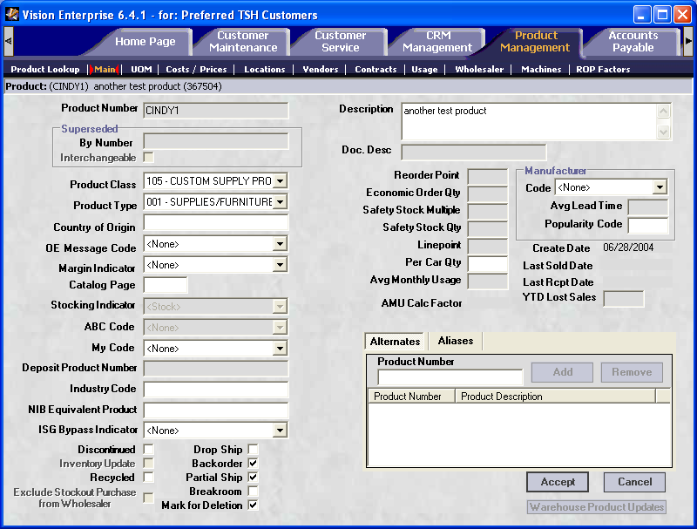

From menu 12.3:

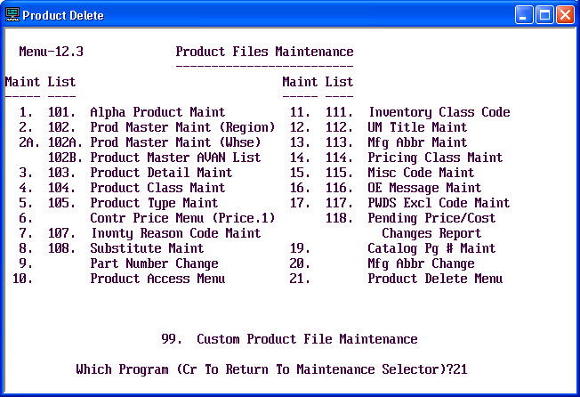

A new menu has been added to Product Maintenance – 21. Product Delete Menu

Since there are many files to process during the deletion of a product the on demand process can be setup with a sleep time and run during off hours.

Prior to running 12.3.21.2 (‘Process Products flagged for Deletion’) the report of items waiting to be processed should be printed and reviewed (12.3.21.1).

If any errors are encountered during the delete process an error report will be generated. This report can be reproduced on menu 12.3.21.3 prior to any future runs of ‘Process Products flagged for Deletion’.

A history report of deleted items can be run on menu 12.3.21.4, minimal information on when the product was deleted is available.
