
Office Products Enhancements
Vision SupplyPoint+ e-store phase II
JumpTech JumpCart™ integration
Order lookup by user, product, order, or invoice
Self-service A/R statements
Sales summary graph
Self-service proof-of-delivery
6 New factors to control search results rank
6 New factors to include/exclude e-commercable items
Download customer usage to Excel
Approval e-mails contain hyperlinks
B-2-C ordering
Multiple brand identities for your e-store
Private label and specialty item visual icons
Custom e-content for dealer items
Miscellaneous VSP+ enhancements

Automotive Aftermarket Enhancements
Activant catalog integration – PartExpert™ & Cover-to-Cover™
Transnet / Translink EDI orders
Generalized fee warehouse support

Order Processing / Customer Service
4 years of sales history on customer profile graph
Will-call delivery method – print tickets on pick-up printer
Retail credit card processing with Protobase™

Inventory Management Enhancements
Build-to-demand kits
Consider delay days in reordering
Consider pending customer returns in replenishment
Zone Picking

Miscellaneous Improvements

Activant™
Vision™ – Release 7.2
3nd Quarter 2005
Copyright © 2005 Activant Solutions, Inc. All rights reserved
Activant, Vision, Vision SupplyPoint, PartExpert, Cover-to-Cover and VSP+ are either registered trademarks or trademarks of Activant Solutions in the US and other countries.
Protobase is either a trademark or a registered trademark of Southern Data Communications, Inc in the US and other countries.
JumpTech and JumpCart are either trademarks or registered trademarks of Jump Technologies, Inc in the US and other countries.
All other trademarks and registered trademarks are property of their respective owners.

Office Products Enhancements

Vision Supply Point+ e-store Phase II
VSP+, the next generation e-commerce system for office products dealers is now available for TSH Vision users! Contact Steve Young at (847) 768-3136 for more information and an in-depth demonstration.
VSP+ e-store gives your customers 24 x 7 web order capability from your unique branded website so you can provide exceptional service at minimal cost—compete and win against your big box competitors.

JumpTech JumpCart integration
SupplyPoint+ e-commerce now supports the JumpTech's JumpCart system letting your customers shop your paper catalog and still have the convenience of placing their orders on the web. It's simple; your customer scans a "jump code" printed next to each item they'd like to order with an inexpensive handheld scanner. When they are finished shopping, they dock the scanner to their desktop PC and their product selections automatically load into a new Vision SupplyPoint+ order on your web site. It's quick and easy and even makes ordering fun!
Vision SupplyPoint+ and the JumpCart system help your sales executives open new doors and keep your best customers better connected. JumpCart is easy to set up and uses inexpensive scanners that are very affordable. It's a super door opener and deal-clincher for your sales team, in addition to being a great quick-input technology for your customers.
Please contact Steve Young at (847) 768-3136 for pricing or more information on how to get started with Jump Tech’s JumpCart and Vision SupplyPoint+.

Order lookup by user, product, order, or invoice
Several new search options have been added to the VSP+ e-store Order History lookup. Users can now retrieve a list of orders and drill down into order detail by selecting a user name, entering order number, invoice number, customer’s PO number, entering a starting and ending date, or entering a product ID. These entries are used as filters to retrieve order information.

Self-service A/R Statements
A new self-service option has been added to VSP+ enabling your customers to look at their open invoices and to print copy of their current aging statement. An aging breakdown is presented on the screen for the customer’s account. The summary includes all orders placed by the customer (e-store and telephone/mail/walk-in) for all users and it can be displayed on the screen or printed. Your users can access the Review and Print Statements function in the Customer Services functions on the My Accounts page.

Sales summary graph

Users now have the ability to review sales usage in a graph form. Review Historical Product Usage in the Customer Services section of the My Accounts page allows your users to see a line chart of their total product purchase dollars by month. The graph shows a summary for all locations, individual locations or stacked lines for each location.

Self-service proof-of-delivery

When Vision SupplyPoint+ is used in conjunction with PocketVision proof-of-delivery, your customers can lookup delivery information right on the web for packages your drivers delivered. Delivery receipt information is displayed for shipped orders by clicking on any order transaction in the Order History list. The time/date stamped receipt information, including the signature of the person who received your packages, is displayed for their tracking convenience – all without a phone call!

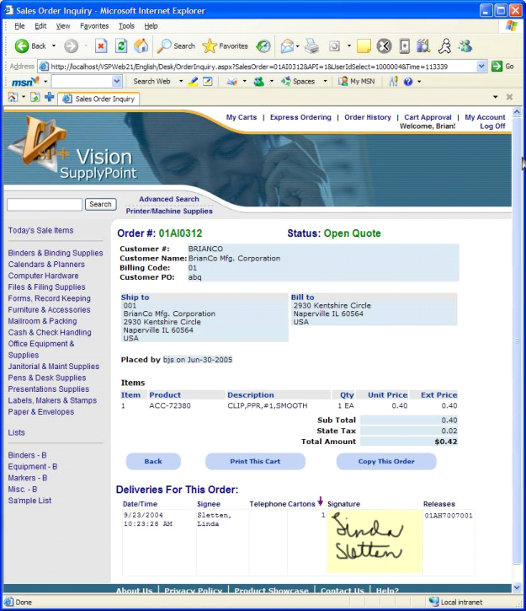
Delivery information, including the signature of the person who signed for the packages can be retrieved by your customers when you user PocketVision and VSP+
Past orders can be displayed, reprinted or copied from to create new orders by clicking on a listed order on the Order History page
6 new factors to control search results rank
VSP+ lets you, the dealer, control how you want to present search results for your customer. This lets you, not the manufacturers, sequence the products that earn you highest margin at the top of the search result stack where they are more likely to be purchased by your customers.

Product Search Weight factors are set through a rules-based table on the Vision SupplyPoint Information maintenance on the Vision Configuration tab. Click on a factor to open a rules table. Right click on a rule line in the table and a dialog box will open allowing you to choose variable conditions that identify sets of products to rank. In addition to ABC Code, manufacturer, price class, product class, primary vendor, stock/non-stock, and wholesaler, you can now also choose a MyCode group, product number, product type, discontinued flag, secondary vendor or drop ship flag as variable options to identify a product or group of products that should be ranked at a specific level. Each rule in the table has a corresponding rank and products are presented in the VSP+ search results form in order from highest to lowest rank.

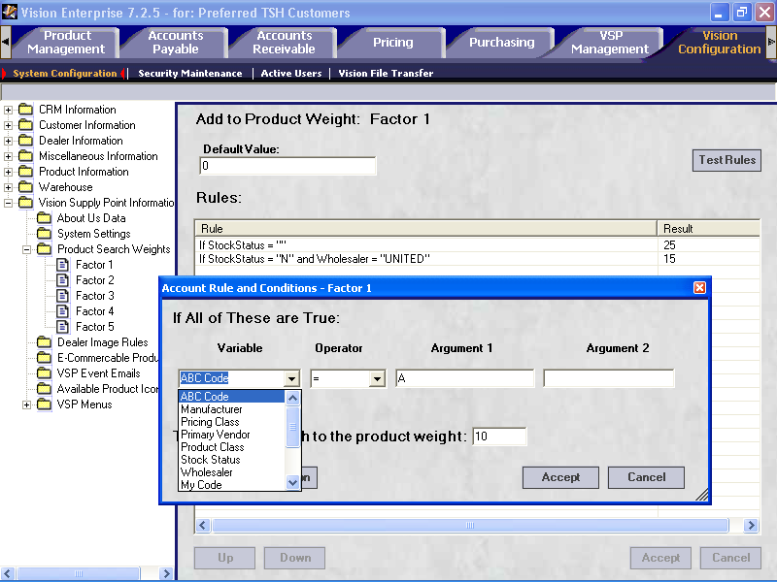
Multiple rules in the table let you set different “weights” for different groups of products
Set the search weight for this group of products. Products with the highest weight will come to the top of the search results
Choose from 12 different variable factors to identify a product or groups of products

6 new factors to include / exclude e-commercable items

E-Commercable product inclusions or exclusions can be defined under Vision SupplyPoint Information on the Vision Configuration tab. Click on the E-commercable Product Rules folder to open the rules table. Right click on a rule line in the table and a dialog box will open allowing you to choose variable conditions that identify sets of products to include or exclude in your VSP+ e-store.

In addition to ABC Code, manufacturer, price class, product class, primary vendor, stock/non-stock, and wholesaler, you may now also choose a MyCode group, product number, product type, discontinued flag, secondary vendor or drop ship flag as variable options to identify a product or group of products that you would like to include or exclude. These e-commercable rules apply to all customers who use your VSP+ site, and are commonly used to exclude categories of higher ticket items from being orderable on the web. Note that product restrictions can also be set at the customer/user level by applying an exclude list in user maintenance.

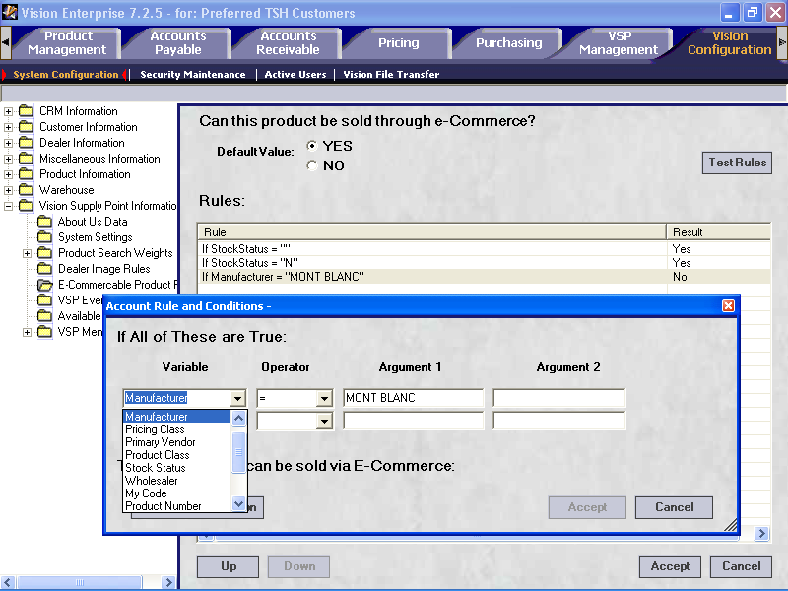
Rules define products to be included or excluded from display and ordering in VSP+
Setup
sellable products for your site in the Vision Supply Point Information E-Commercable Rules folder

Download customer usage to Excel

You can give your VSP+ administrative users the ability to download an Excel spreadsheet of their usage. This spreadsheet contains order information including product level detail, quantities, dates, and pricing. Enable this feature by checking the “Permit product usage e-mail from VSP+” on the Customer Maintenance > Main > Handling Options panel.

When you permit a customer to download usage, their administrative-level users will see an additional paragraph on the VSP+ Review Historical Product Usage graph page, along with a link directing to “Click here for detailed product usage via e-mail”. Upon click, a back-office Vision process gathers usage details for the customer and sends an excel spreadsheet to the user. Information for all users in the company and for orders place through both VSP+ and back-office will be included.

Approval e-mails contain hyperlinks
E-mail order notices sent to VSP+ order approvers will now contain a hyperlink to your VSP+ e-store. The user will still be required to go through the login process, but they will be taken directly to the site to more quickly review their queue of orders waiting for approval.

B-to-C Ordering
VSP+ now supports B-to-C browsing and ordering. A casual web user who is not yet your customer now has the ability to browse your e-store and place an order without being first setup as a customer.

When setting up VSP+ you have the ability to choose a “guest” customer number that will be used to provide pricing for any anonymous shoppers. A guest may browse the catalog, buy items, create a shopping cart and check-out all without having a system logon. The anonymous shopper will receive whatever pricing you setup for your default guest customer.

Guest shoppers are restricted to a credit card payment method and they are prompted to key in shipping address information prior to checkout.

In order to give you control and protection, as well as the opportunity to turn a guest customer into a repeat buyer, incoming orders from a guest customer are automatically placed on hold and routed to the home page of your designated service or account rep(s) through the VSPOrderEntered CRM routing event. This gives you the ability to review the order for pricing and delivery location sanity before it is automatically shipped. Your back-office user(s) can then follow the link from their home page into the Current Order form, review the order, pricing, etc – make any changes and accept.

Private label and specialty item visual icons
VSP+ now offers the ability to let you attach graphic icons to specific products for visual display on the product search result page. Up to three icons can be displayed in a row underneath the product description. This gives you the ability to highlight your private label products, show that MSDS sheets are available, indicate contract items, etc.
Dealer icons can be assigned to categories of products through the Dealer Images rules table under the Vision Configuration > Vision SupplyPoint Information folder.
Multiple brand identities for your e-store
Multiple VSP+ e-stores identities can be created to represent your different business brands. Graphic images, contact information and a unique starting point URL can be added to the Vision Configuration > Vision Supply Point Information > About Us data folder for different facets of your business.
Dealers have the ability to setup multiple faces of their e-store, all of which point back to the same Vision back-office database. Customers are given the URL that drives them to the e-store site face which matches their market. Dealers can use this capability to promote multiple brands, for example, establishing a different identity for their coffee service and breakroom business, from office supplies. Another example might be to separate government business or a minority business coop. Used in conjunction with Vision’s Company ID that can be attached to each customer record to drive identity on your business documents, your customers experience a more personalized business face.

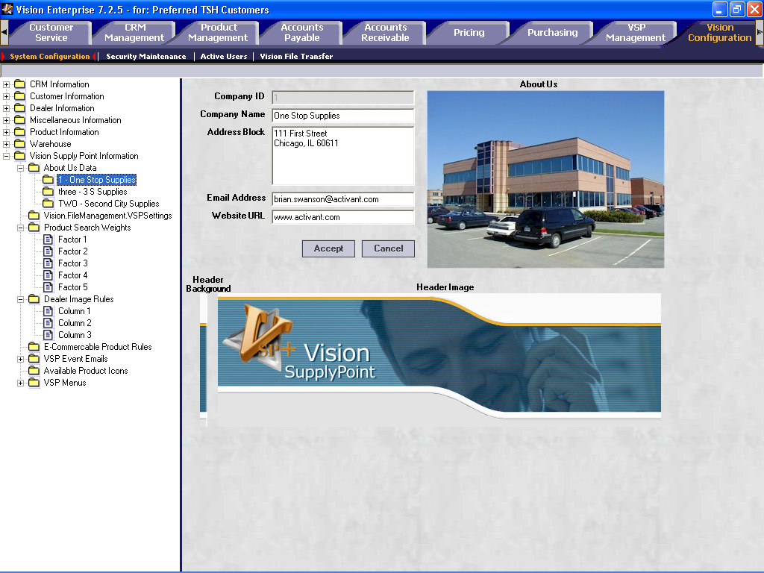
Customize your VSP+ e-store with a graphic header that matches your corporate branding
Assign the unique URL that will launch to this branded site
Setup multiple About Us launch pages and publish multiple site identities

Custom e-content for dealer items

VSP + allows you to include rich content for your own private brand items or other products which are not included in content supplied from United Stationers or S.P. Richard catalog databases. Any item that is defined in your Vision database can be accessed through your VSP+ e-store, with the same rich visual content and descriptions that appear from catalog. Wholesaler content can also be overridden through this process. Users will find and order your custom content items through both product searches and through the catalog drilldowns.

Custom content can be setup on the Product Management > Custom E-content form for users with the Purchasing Manager VSP+ role authorization.
Setup your custom content on the Product Management Custom Content form
Categorize your items so they are visible in category drill-downs

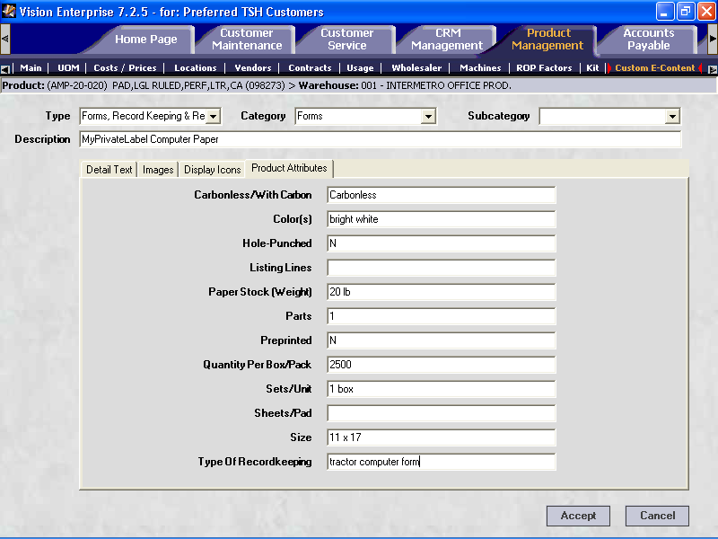

Enter detailed product attributes that are uniquely appropriate for each type of item
Enter extended descriptions, attach large and small graphic images, and display icons

Miscellaneous VSP+ enhancements

- A new field has been added to Customer Maintenance > Main form > Handling options which allows incoming VSP+ e-store orders to trigger a CRM alert on the home page of a selected Vision user or user. The "CRM Event for Electronic Orders" generates a notification that an order from the customer has arrived – no action needs to be taken -- the order will still be processed normally through Vision. This event can be used when you want to monitor the incoming orders from a specific customer, but not necessarily intervene with their processing. The user routing is determined by the event parameters defined on the CRM > Event form for the VSPOrderEntered event.

- A new field has been added to Customer Maintenance > Main form > Handling options which allows all electronic orders (VSP or EDI) for this customer to be submitted as quotations and stored on a back-office user’s home page for review prior to processing. The "Manually Review Electronic Orders" flag (which is only available if the CRM event is turned on) causes all electronic orders (VSP or EDI) for this customer to be submitted as quotations rather than being pushed through the system as orders. If no action is taken to turn the quotes into orders, the orders will not be processed. This event should be used when you want to explicitly intervene and "accept" each incoming order from a customer.

- VSP+ Favorites lists include default quantities and user-supplied comments can be sorted in several ways, and can be displayed in an abbreviated format reassembling a requisition list. Two fields have been added to the My Existing Favorites Lists page accessed from My Accounts page on the VSP+ e-store.

- VSP+ Express ordering now allows products to be added to a favorites list and now allows 20 products to be entered at one time.

- Vision CSR’s may download a spreadsheet containing information about current VSP+ users, including their e-mail addresses. This option is available on Vision back-office menu 25-2-9.

- The VSP+ phrase “on account” used for selection of payment method has been changed to say “card on file” if a credit card is configured at the billing code, ship-to, or customer level.

- The Firefox™ and Internet Explorer™ 5.x browsers are now supported by VSP+.

Automotive Aftermarket Enhancements

Activant catalog integration – ePartExpert & Cover-to-Cover

Vision is now fully integrated with Activant’s industry leading aftermarket parts catalog along with expanded visual graphic content provided in Cover-to-Cover. Vision users can search for parts in the catalog, punch out to see part pictures, warranty info, technical bulletins and other product information supplied by the manufacturer to help them more accurately identify the right parts and provide value added information to their customers at time of sale.
Options allow customization of the catalog lookup interface by user – tech specs can be turned on/off; lookup by category code; interchanges, and specific conditions.

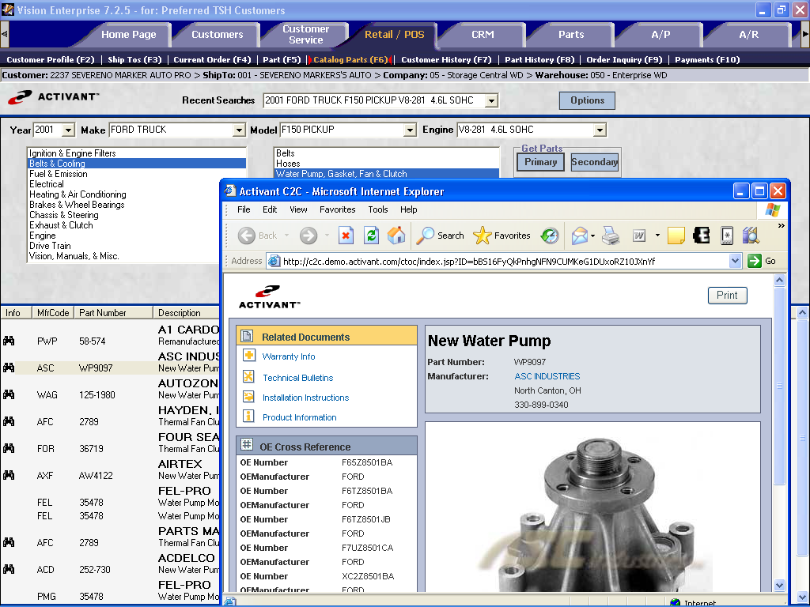
One-click e-mail or print pictures or technical information for your customers
Direct access to warranty info, technical bulletins, install instructions, product info, schematics, etc.
Punch out to cover-to-cover graphic data from the catalog search result

Transnet / Translink EDI orders

Inbound 850 Transnet purchase orders from customers and outbound purchase orders to vendors can now be sent and received through MISG’s Translink gateway. A new X-12 EDI menu has been added to menu 1-5 to support the setup of translation files, exchange of order transactions, management of order batches and correction of errors.

Generalized fee warehouse support

Vision’s fee-based warehouse module has been enhanced to support automatic transfer of sales information for vendor owned inventory via a printed report, e-mail, fax, or nightly ftp to the vendor. A fee-based warehouse allows you to sell inventory which is owned by the vendor through Vision’s normal sales order process.

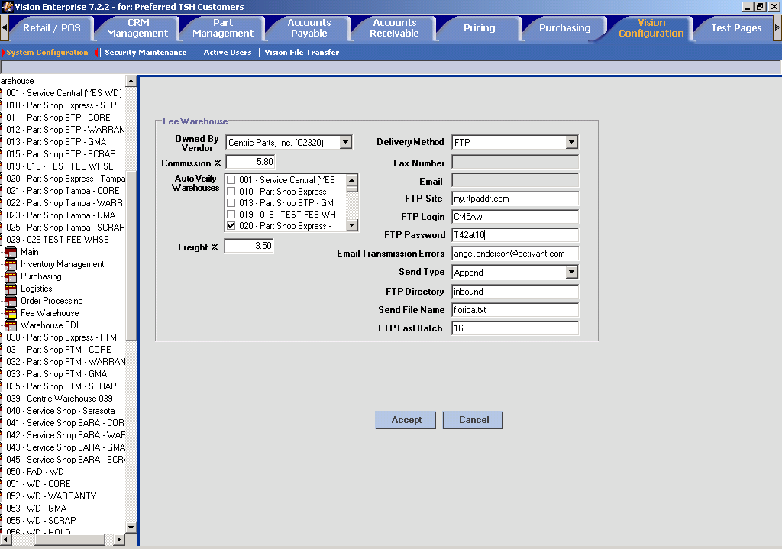

Order Processing / Customer Service

4 years of sales history on customer profile graph

The Customer Profile form has been expanded to show a rolling 4 years of sales graphic sales information.

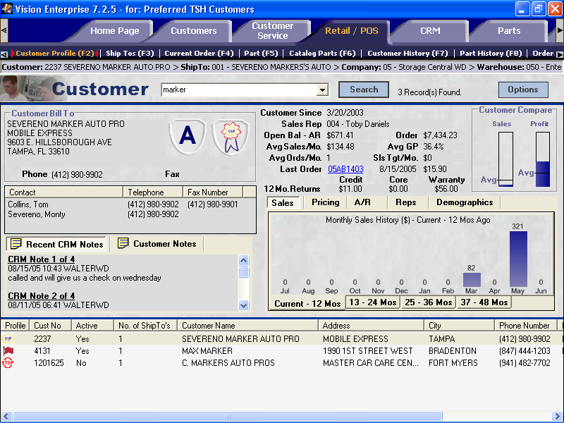
Click on a tab to look at prior year sales – rolling 48 months now displays

Will-call delivery method – print tickets for pickup

The Customer Service > Current Order form has been modified moving delivery method to the header portion of the screen and splitting the line item portion of the screen into two tabs.

A will call delivery method has been added to allow a customer who is typically setup to print a picking document in the normal warehouse flow to divert to a special will-call printer for customer pickup rather than delivery. A will call print queue has been added to Vision Configuration > Warehouse Maintenance > Logistics form.
Delivery method relocated to header. New Will Call method redirects document to printer at the Will Call counter

Line item entry split into two tabs, w/less frequent info on the More… tab
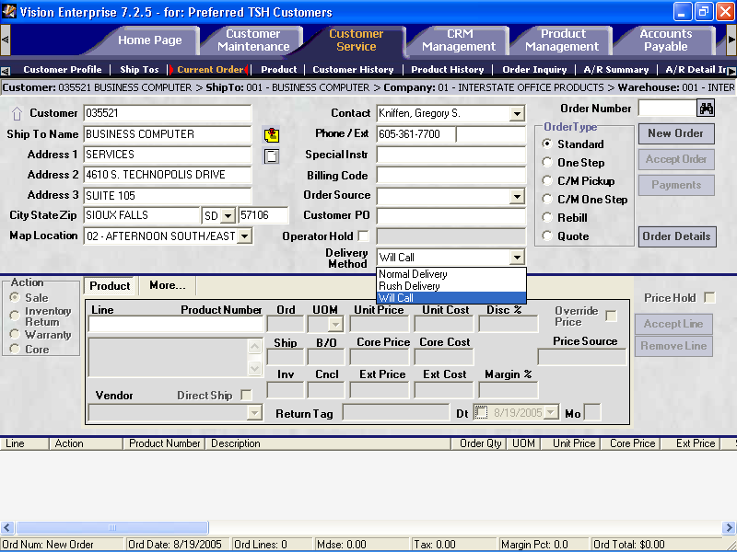

Retail credit card processing with Protobase

Credit card orders can be authorized and settled in real time at order entry time in Vision. Vision uses Southern Datacom’s Protobase to provide connectivity to a large network of electronic payment processors and banking institutions. Protobase translates data formats between credit card transaction, payment processor and bank enabling you to switch to electronic card verification while keeping your existing payment processor and bank relationship.

When Protobase retail mode is selected, credit cards are validated at point of sale. An electronic transaction is sent out either via dial-up modem or over the internet to the credit card processor. The card information is validated and charged or denied. If denied, a message displays on the Vision order form allowing the user to enter a different card number or choose a different payment method.

Online credit card validation requires a separate Protobase license. For more information on the options available for online credit card validation, contact Steve Young at (847) 768-3136 or the Vision support team.

Inventory Management Enhancements

Build to demand kits

Build to Demand kits have added to Vision allowing a kit to be defined which is made up of other items which can be selectively chosen at time of order. Build-to-demand kits are useful when a kit contains optional items which do not make sense to stock as a part. A Build to Demand option has been added to kit maintenance on the Part / Product Maintenance tab. Kit components can be added to a master item at the global level – and will apply to all regional warehouse locations.

The benefit of defining a kit, as opposed to just selling the individual components is that the kit offers the ability to analyze sales of both the kit and sales of the components, while replenishment for the components considers all demand.

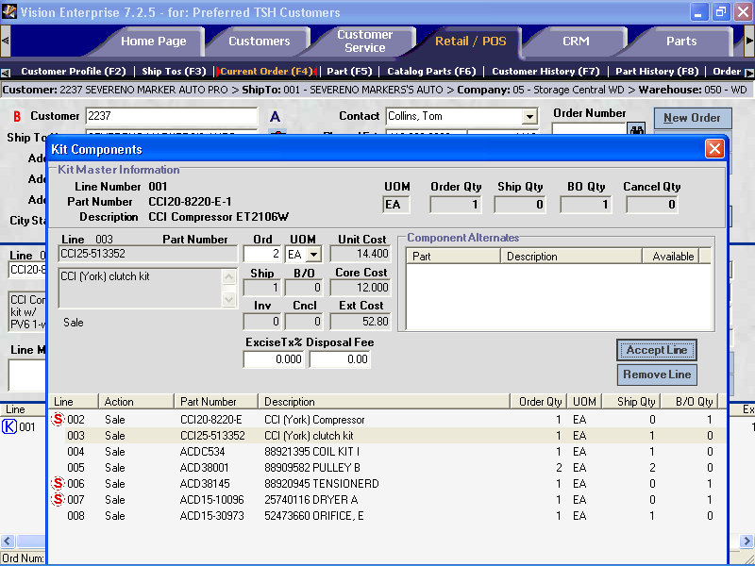
Kit Component list pops on the current order form when a kit item is entered
Default parts and quantities are listed. Lines can be added or changed
Sell price is calculated from remaining kit items at cost, plus markup % percentage

Consider delay days in reordering

A new delay days field has been added to Part Maintenance, to Part Maintenance > ROP reorder point maintenance and to the Purchasing > ABC model form. Delay days are factored into replenishment calculations so that you can hold off on placing a reorder for a certain number of days after stock levels reach your normal reorder point. This is particularly useful for slow moving items or on high return rate items. This lets you delay reordering on the expectation that the item may not move again quickly and with consideration that there is a higher than normal likelihood of a recent sale being returned. Reorder delay days help you make sure that you don’t order another replacement item, only to find that a slow moving item is returned and now you have two that may take a very long time to sell.

Consider pending customer returns in replenishment

An additional field has been added to Vision Configuration > Product Class Maintenance to allow the product class to be flagged to consider pending customer returns during the replenishment process. A new checkbox “Consider Pending Customer Returns” has been added. End-of-day and on-demand inventory replenishment routines have been enhanced to consider pending customer returns as “available” in the recommended buy calculation if the product class associated with the part is flagged to consider pending returns and a two step credit memo has been entered on the system, but not yet verified.

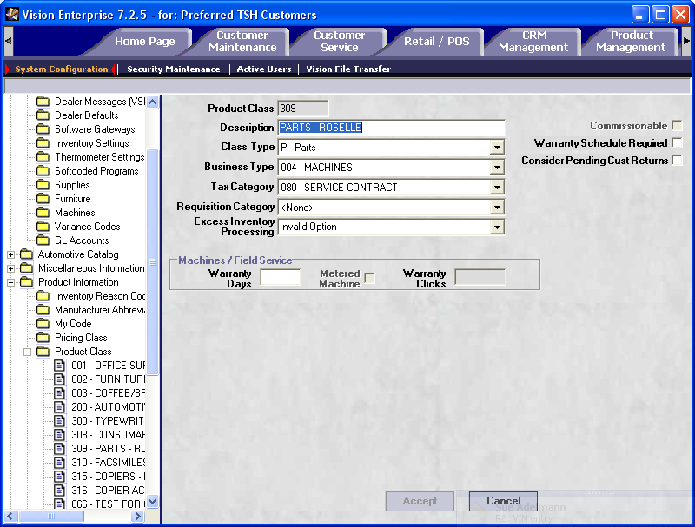

Zone Picking

Vision’s warehouse management system now offers you the ability to setup a warehouse to pick products by zone for improved picking efficiency, or for situations where products are bulky or heavy and not appropriate to move down a pick line. In a zone pick warehouse environment, pickers are split into separate documents by zone, then married together at the end of the line or at a shipping station. A separate printer is setup in each zone to print the sections of orders that need to be pulled from the zone. Items are picked and delivered to the verification or shipping station, where a final invoice or packing list is printed.

Zone printing can be setup for a warehouse by associating print queues with each pick zone on the Warehouse Maintenance > Logistics form. Zone printing will occur and will override any other picker print queue when zone printers are entered on this form.

Miscellaneous Improvements

- The PocketVision delivery dashboard has been modified to no longer populate automatically when clicking on the customer service tab to speed loading of the tab. Users need to click the refresh button in order to view the current delivery operations graph.

- Modified Accounts Payable menu for Voucher Deletion.

- Removed ABC and ROP calculations from End-of-Year jobstream.

- Modified faxing of statements to use A/R contract from the contacts file instead of the A/R contact on the customer record.

- Added the ability to exclude inactive customers from the customer master and customer detail listings.

- Allow entry of individual EDI vendors other than the ones displayed When doing an 1 step EDI by selected vendor.

- Added freeze date to reorder points upload process.

- Add automotive “Receipts not Vouchered Report to Office Supplies menu 3.13.

- Corrected e-order update to pull default ship-to or first ship-to.

- Added MyCode prompt to stock status reports.

- Added AP End-of-Month to the automotive menus.

- Added “Clear Order Lock Byte” to Supply and Auto menu 12.6.8 and Menu 26.6 on Windows-based Office Products systems.

- Added update of vendor master “Inventory Vendor” flag to vendor conversion.

- Modified Credit Card Processing (Protobase): when a release/invoice is voided, the release field for comments is cleared as it is used for the authorization number.

- Corrected vouchering issues for Drop Ship order linked to PO.

- Modified contract price conversion, if no unit of measure is specified, get the lowest unit of measure from the product file.

