
Office Products Enhancements
New next generation Vision SupplyPoint: VSP+ powerful, integrated e-commerce

TPA buying group – central metrics collection and EDI gateway for vendor and member invoices

Automotive Aftermarket Enhancements
General Motors ADI™ full program support

Accounting
Microsoft Great Plains 8.0 approved with TSH Vision

Sales Analysis
Turn and Earn report includes manufacturer, pricing, and product class selectivity
Added Category Month-to-Date Sales Report
New Customer Transactions by Product Class report

Inventory Management Enhancements
New audit rated cycle counts and count scheduler
Push product vendor fields to multi-locations
Improved visibility of incoming customer merchandise returns
New Build to shelf kits

Tools and Utilities
New utility to mass change non-stock items to stock

Miscellaneous Improvements
De-activated back office maintenances

THE SYSTEMS HOUSE
TSH Vision – Release 7.1
2nd Quarter 2005
Introduction

Release 7.1 delivers something for everyone!

For office products dealers, 7.1 marks the first official release of VSP+, The Systems House’s next generation Vision SupplyPoint e-commerce system. VSP+ was developed by the Systems House from a robust e-commerce toolkit based on the latest Microsoft .NET technology infused with TSH’s 25 years of office products industry expertise. VSP+ is fully integrated with TSH Vision in real-time and delivers the best new feature suggestions that we’ve collected from TSH customers and industry leaders. VSP+ is flexible and extendable and will continue to evolve and advance on a regular basis in step with Vision in future software releases.

For automotive aftermarketers and large warehouse environments, we’ve redesigned our cycle-count system to provide an audit-rated, schedule-based count system. The new cycle count can replace your annual physical inventory process—minimizing business disruption and overtime cost. The new process supports both Pick-by-Product and Pick-by-Order inventories and can be used with or without barcode scanners.

Vision 7.1 also includes many small fixes, enhancements, and improvements from TSH customers that can help you save time and simplify operations.

The best business practice concepts and tools delivered within Vision 7.1 represent one facet of the ongoing commitment that The Systems House continues to make to ensure that our customers always maintain a leader’s competitive edge.

Copyright © 2005 The Systems House, Inc. All rights reserved
The Systems House, The Systems House logo, Vision, TSH Vision, Vision SupplyPoint, and VSP+ are either registered trademarks or trademarks of The Systems House, Inc. in the United States and other countries.
Protobase is either a trademark or a registered trademark of Southern Data Communications, Inc.
IBM and AIX are registered trademarks of IBM in the United States.
Linux is a registered trademark of Linus Torvalds.
Thalerus and Vendere are either trademarks or registered trademarks of Thalerus Group.
Wrenchead and Nexpart are either trademarks or registered trademarks of Wrenchead, Inc.
D-Force is either a trademark or a registered trademark of Independent Stationers.
Microsoft, Windows, and Great Plains are either registered trademarks or trademarks of Microsoft Corporation in the United States and/or other countries.
All other trademarks and registered trademarks are property of their respective owner

Office Products Enhancements

New next generation Vision SupplyPoint – VSP+ powerful, integrated e-commerce
VSP+, the next generation e-commerce system for office products dealers is now available for TSH Vision users! Contact Mike Gerlach at (847) 768-3144 for more information and an in-depth demonstration.
VSP+ e-commerce gives your customers 24 x 7 web order capability from your unique branded website so you can provide exceptional service at minimal cost—compete and win against your big box competitors.
Highlights of just a few new features include:
- Fast, simple ordering screens with a contemporary look and feel and your unique branded identity. No pop-ups!
- You – the dealer – can control the ranking of products search results!
- Favorites lists (mylists) at the dealer, customer, user level; exclude lists at the dealer and customer level
- Order limits, approval routing, and budgets – maintainable by your customer on the VSP+ website, or by you in Vision
- Pricing, availability, ordering and history lookups are integrated with your Vision database in real time! – One database for reporting!
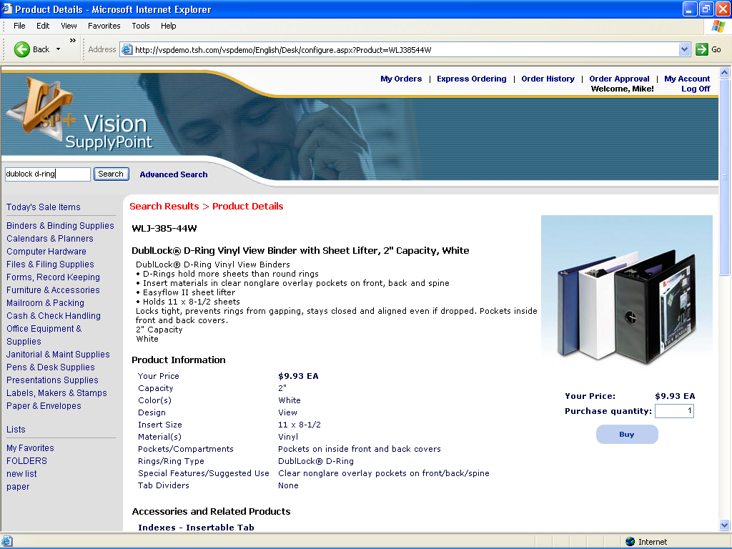
TPA buying group – central metrics collection and EDI gateway for vendor and member invoices
Phase II vendor invoicing automation has been delivered for TriMega Purchasing Association’s central buying group facility and for TPA members who use the TSH Vision system. TPA uses a customized TSH Vision system which serves as a clearing house to aggregate member purchases for optimized pricing and vendor rebates. The TPA system manages inbound and outbound EDI transactions between members and vendors. 850 purchase orders are received from members, product usage information is collected and aggregated, PO’s are consolidated and forwarded to vendors. 810 vendor invoices are received from vendors and 810 invoices are passed back to members who may use a variety of different system platforms.

TPA members who are TSH Vision users automatically receive TPA invoices. Vendor information is extracted and validated against member purchase orders and receipts and matching invoices automatically create a payment voucher for TPA for the vendor purchase. Rejected invoices are reported in an error report and can be manually reconciled by the members. Variance parameters are evaluated during the voucher creation process, comparing receipt quantities and prices against vendor invoiced quantities. Vouchers are created in a “hold” state when quantity or price variances lie outside of tolerances.

Automotive Aftermarket Enhancements

General Motors ADI full program support

General Motors Service & Parts Operations’ ADI (Accessory Distributor Installers) procurement program allows authorized distributors to stock, sell and install accessories for GM dealers within their territory. The ADI program allows GM to forecast accessory demand and, as a result, offers distributors who participate in the program an advantageous return policy for accessories they stock which can otherwise very rapidly become obsolete.

Within the ADI program data files are exchanged through a secure ftp site between the distributor and GM in order to automate inventory replenishment. The distributor provides an initial sales history and daily sales. GM sets reorder points based on this information and creates EDI Purchase Orders to its suppliers based on demand reported by its ADI distributors. These EDI purchase orders are picked up from the ftp site and loaded and activated on the distributor’s system, rather than allowing TSH Vision to create suggested buy purchase orders. When an ADI distributor participates in the program and allows GM to manage reorder points and initiate the PO’s, GM will automatically accept returns of any obsolete parts procured as a result of their replenishment forecast.

The following transactions are exchanged between TSH Vision and GM in the STAR (Standards for Technology in Automotive Retail) format. All transactions are now supported in TSH Vision.
- Daily Sales & Inventory (Sent by ADI to GM)
- Daily Orders to suppliers (Sent by GM to ADI)
- Daily Material Returns (Sent by GM to ADI)
- Daily Parts State (Sent by GM to ADI)

Configuration parameters to access the GM ftp document drop zone for the ADI file transfers are set on the Vision Configuration >System Configuration > Miscellaneous Information > ADI fulfillment form. File drop and pickup times are dictated by GM and setup through Vision’s batch process scheduler. On demand file transmissions can be run ad hoc by clicking the send button on the ADI fulfillment form. GM accessories can be flagged for ADI fulfillment by checking the box Use GM ADI fulfillment on the Part Maintenance > Main form.

Accounting

Microsoft Great Plains 8.0 approved with TSH Vision

Microsoft Great Plains version 8.0.2 has been tested and updates have been made in TSH Vision to support integrated accounting with this latest release of Great Plains. Distributors who use Great Plains accounting may want to upgrade to the current release to continue Microsoft support. TSH Vision supports full integration with Microsoft Great Plains 7.x and 8.x, in addition to Vision’s own native A/R, A/P and General Ledger.

Contact The Systems House for more information on upgrading to Microsoft Great Plains 8.0.

Sales Analysis

Turn and Earn report includes manufacturer, pricing, and product class selectivity

The inventory Turn and Earn Report has been enhanced to offer selectivity by manufacturer, by pricing class, and by product class. This report presents inventory turnover metrics by vendor, by item including 6 month sales, costs, hits, average inventory $, GP%, current on hand, reorder point, # of inventory turns, ABC (velocity code), and earnings per turn. The new selectivity supports analysis of narrower segments of inventory.

Added Category MTD Sales report

A new sales report recapping month-to-date and year-to-date sales has been added to office products menu 11.20 (already existed on Automotive menu 7.14).

The Category MTD Sales report offers selectivity by company or All, Salesperson or All, Customer or All, Manufacturer or All for a selected month in the current or previous year. Report is sequenced by company, by salesperson and totaled by Product/Part Class or by Manufacturer. Month-to-date and Year-to-date figures for sales, cost, and gross margin are totaled.

New Customer Transactions by Product Class report

A new sales report summarizes order release activity by product class, totaling dollar values of sales transactions, new inventory returns, core returns, and warranty returns for a customer or group of customers.

The Customer Transactions by Product Class report has been added to Office Products menu 11.19 and Automotive menu 7.16. The report offers selectivity by company or All, warehouse or All, for a customer or list of customers over a specific date range. The report summarizes order release value by company, by warehouse, by customer, by product class, by order line transaction type.

Inventory Management Improvements

New Audit rated cycle counts and count scheduler

Efficiency-savvy distributors are moving toward a practice of scheduled cycle counts that leave a strong audit trail and pass all stocked inventory on a regular basis as an alternative to an annual full physical inventory. Cycle counts can be less disruptive than a full physical and are typically less costly to perform because existing staff count during normal working hours rather than an extended staff on overtime over a weekend. Cycle counts also allow you to focus on smaller segments of your inventory with varied frequency depending on risk, velocity, or any number of other factors. Scheduling cycle counts and leaving an audit trail of last count dates at the item level ensures that all inventory is touched at some point.

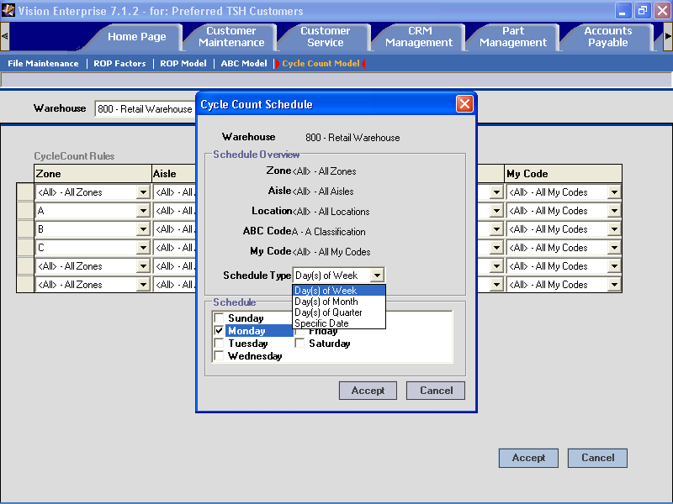
Each row in the count schedule pinpoints a physical area of the warehouse, or group of products to be counted together.
Clicking on a row in the schedule opens up the schedule form, where you can choose the right count frequency for the selected group of parts.
Count schedules or models can be setup ahead of time for each warehouse location.

Vision’s new cycle count process is automated and audit verifiable – important so your results are acceptable to banking institutions that may require audit compliant processes for inventory financing. Vision’s audit rated cycle count supports both barcode scanning and paper count entry and you can mix techniques based on available scanners in your environment.

Vision’s cycle count scheduler lets you build a count plan or model which pinpoints segments of your inventory that you want to count at specific intervals. You can define different frequency schedules for different physical locations within your facility or groups of items in your warehouse. You can setup count frequency schedules to produce count sheets on specific days of the week, on specific days of the month, on specific days of a quarter or on a given date.

Count schedules are defined on the Purchasing > Cycle Count Model form. Access to this form requires the Purchasing Manager role security level. Bar-coded count sheets are printed, counts are updated, and variance adjustments created on the Vision back office audit rated cycle count menus. Audit rated cycle counts are available for both Pick-by-Order and Pick-by-Product inventory management models. The count processes are located on the back office Physical Inventory menu at 3.6.4 and 3.6.5.

Once you’ve established count frequencies for your inventory items, run the tag creation process and print count worksheets. The process prompts for an activity date and all unfinished counts for items scheduled to be counted through that date will be selected. If a scheduled count was missed, it will automatically print in your next count cycle batch. You will have the option to add additional products, or further filter the items to be counted and count sheets will be printed. Counts can be scanned in through the RF scan option or keyed in and a variance report produced for management recount review. Once counts are accepted, inventory adjustments are made automatically and the Part History form is updated with the results of the count. A cycle count transaction is added and time date stamped in the Part History for each part counted, even if the count did not produce a discrepancy.

Push product vendor fields to multi-locations

Vendor information on the Product / Parts Management tab > Vendors form can now be maintained at one warehouse or facility and pushed to other locations. The vendor information fields have been added to the list of fields which can be updated to one or more other locations by clicking on the warehouse part update button on any of the maintenance forms. This may be particularly useful for pushing a PO cost from one location to other locations.

You may now also update global product / part master fields from regional part information. An update global option has been added to the warehouse update form.

Improved visibility of incoming customer merchandise returns

TSH Vision supports two types of customer merchandise returns on the Customer Service > Current Order form. A one-step return is suited for retail or counter sale situations when merchandise is returned and a credit is issued immediately. A two-step return (sometimes called an RGA or RMA) process is available when a return authorization number is given over the phone with merchandise collected and a credit is issued at a later date.

Previously Vision offered limited visibility of two-step pending returns which were in process between the time the return authorization was issued and the returned items were collected and credited. Visibility of pending returns has been improved in this release. Buyers can now better consider expected returns prior to purchasing and sales and service associates can now gain awareness of incoming expected returns for high demand and out-of-stock items.

- A Pending Customer Returns column has been added to the Replenishment Action Report to assist buyers’ analysis. The pending return quantity is visible on the report but not automatically factored in replenishment, because varying factors can effect the successful completion of the return.

- A new Customer Returns column has been added to the Warehouse Stock panel on the Product / Part lookup forms (on the Customer Service and Quick Order tabs)

- A new option has been added to the Product / Part History forms (on the Customer Service and Quick Order tabs) to display pending credit memos when filtering by open orders.

- A Pending Customer Return rebuild program has been added to Purges and Rebuilds menu 28.2.1.27.

New Build to shelf kits

Kit and assortment logic is being added to TSH Vision in this and upcoming releases. In this first release, a new kit maintenance form has been added to the Part / Product Maintenance tab and “Build to shelf” type kitting has been enabled. Kit components can be added to a master item at the global level – and will apply to all regional warehouse locations.

“Build to shelf” kitting suits small/simple collections of items which are routinely stocked and bundled together for convenience at time of sale. The benefit of defining a “Build to shelf” kit, as opposed to just selling the individual components is that with the kit you have the ability to analyze sales of both the kit and sales of the components, while replenishment for the components considers all demand.

A negative purchase order removes kit components from inventory and serves as a work order build your kits. As kits are assembled and placed on a shelf, finished kits are added to inventory through receipt of a purchase order for the finished master item or through an inventory adjustment. (Tip: Create an inventory adjustment code for “Kits added to inventory” on the Vision Configuration tab > Products > Inventory Reason Code form).

At time of sale when an order is placed for a kit item, usage statistics are updated for both the finished/master and component items. A kit item is treated like any other item in order processing. Note that Cost, price and other attributes of the master item need to be defined by the user in Part / Product maintenance. The finished/master kit item should typically be identified as a stock item and sourced from you as a vendor (or a generic miscellaneous vendor). If you allow the kit master item to backorder, you can create a purchase order to yourself that is a work-order reminder to build more kits when needed.

Tools & Utilities

New utility to mass change non-stock to stock item indicator

A new process exists in back office Vision file maintenance (menu 12.3.22 in office products and 13.3.22 in Automotive) to allow mass change of a non-stock item to a stocked item, and push of the item to designated warehouses. This tool can be used to simply the process of setting up a group of existing inventory items for automatic replenishment, when a decision has been made to stock rather than purchase.

The process prompts for a comma delimited (csv) file name. The file will contain a product or part number in the first column, and a dash-delimited warehouse string in the second column.

The process will validate that an item exists in the global part/product file, then check for the item in each specified warehouse. If the part/product already exists in a warehouse as a stocked item, it will be skipped. If it exists as a non-stock item, it will be changed to a stocked part and, if it is a warehouse configured for Pick-by-Product processing a default bin location will be set to NEWITEM if no bin location exists. If an item does not exist in a specified warehouse, it will be created as a new stocked item, with defaults set from the global item record.

Miscellaneous Improvements

Deactivated back office maintenances

Several back office menus have been deactivated and these functions are now exclusively available in the TSH Vision graphical interface (GUI). The deactivated functions have generally been improved in the TSH Vision graphical environment in past releases over the past year -- typically new fields have been added to the graphical screens to support new Vision features. The older back office screens are being deactivated to help you avoid data integrity and consistency problems that may occur in your database if users continue to the older back office screens.

See the attached spreadsheet for a list of the specific menu items which have been deactivated. Note that the these functions will remain on the back office menus, so your users won't face confusion with re-sequenced menu numbers. A menu message will direct the user to Vision GUI, should they access a deactivated back office menu function.

Other improvements:

- One Step EDI will now call each vendor's EDI process to check for manually entered PO's. This ensures that manually created PO’s are transmitted automatically in the next EDI cycle even when no system generated PO’s need to be sent to the vendor. #23402

- Modified PO Print to allow print of office products wholesaler vendor return PO's. Modified office products EDI to not select wholesaler Vendor return PO's for transmission; the negative return PO’s are used to pick product for the return. Also, allow PO Print for wholesalers from menu 7-102. (But not for “ALL’ option) #32361

- Enabled Product Label Print, so labels can be immediately printed on AUX printers. #AB440

- Updated GUI Accounts Payable tab to better support TSH Vision standard accounting in addition to Great Plains. Added the ability to delete held vouchers. #AC283

- Removed obsolete (H)old logic from Manual Verification to avoid user confusion on a function which is not used. #AD091

- Corrected the Bulk Verify process (for standard orders) and the order save process (for one-step and rebill orders) to retain cost values if overridden by the operator #29514

- Soft coded all picker print routines, so users can call their own custom print routines from Vision base software. Modified the following picker prints: Pick-by-product Plain, Laser, Laser No Tag, Pick-by-order Plain, Laser and Summary Pickers. #AD473

- Support follow-ups not attached to a customer number to be saved on the Home Page. #AE256

- Changed the update process to ensure all product master warehouse files are updated consistently if a new Special Item is created during a field service FS Call or Visit Entry. #AE634

- Added fields to standard TSH Vision conversion tools, along with a new Contact conversion. #AE756

- In the replenishment reorder point calculation process, zero the product detail EOQ field if "calculate EOQ" is not checked on the Purchasing > ROP model form. #AE715

- Added support for local AUX printing to GUI retail order processing. #AE920

- Modified product update from spreadsheet. When updating PO Cost, if loading an effective date and cost, the PO Cost will be loaded into the New PO Cost field. If it is for the primary vendor, the effective date will also be loaded; otherwise, only the PO Cost for its appropriate vendor will be loaded. #AF709

- Corrected cash payment processing flow to allow for an open amount when a cash discount is bypassed due to no 'CASHDIS' write off code being setup. #AF909

- Corrected problem with date check validation displayed when closing G/L month. #AG042

- Added new Field Service Credit Card Sales report run during EOD and a reprint from menu 2.9A.

- Enhanced PO Print to support multiple copies on Windows server systems. #AG290

- Credit Memo Picker Print modified to now include map location description. #AG319

- PO Print processes have been changed to sort negative POs by warehouse location, where warehouse location is the combination of the warehouse zone concatenated with the warehouse location. Regular POs (positive POs) will still sort by line number. Also the laser version of the PO Print has been modified to display the zone as part of the warehouse location in the same way the non-laser version does. #AG395

- Added contract furniture damaged goods release processing to EOD. Modified description that prints on the furniture Damage Repair report. #32551

- Added job function Prospect Create to Sales II role to allow user to perform limited customer updates. The Sales II role allows access to the Customer Maintenance > Customer Search, Master, Ship-to Main, and Contacts forms. This role, used in conjunction with pre-set customer templates, enables sales associates to add and maintain basic customer and prospect information (such as name and address) while credit limits and accounting information are defaulted from a template and can not be accessed. #32822

- Enabled Physical Inventory processing to allow concurrent inventory individual warehouses or ALL warehouses. #AB482

- Corrected PO process which was overwriting EDI transmission instructions when an order was entered on credit hold, processed through a transmission cycle, then later released from credit hold. #AE178

- Improved format of Amount Not Vouchered column on Receipts Not Vouchered report when multiple vouchers are been entered for a single receipt. #AE941

- Changed port number assignment format on Windows systems, zero padding when port # is assigned to match port retrieval format. Mismatch was causing orders generated by low-number peon processes to not be selected for order release processing. #AE986.

- Modified Bulk Verification to support Complete Invoice During Shipping Process logic for retail orders. #AE980

- Modified Replenishment processing to add temporary items to the replenishment warehouse transfer order if quantity available is less than zero rather than backordering from the primary vendor. #31698

- Modified Independent Stationers Group Product Load process to match their change in meaning of stock indicator flag from “S” to “N”. #AD912

- Added a new credit memo pickup ticket print queue to the Vision Configuration > Warehouse > Logistics form. This allows credit pickup tickets to be routed to a different print queue than the user’s standard order printer. #AF630

- Corrected a PO sort sequence problem when printing multiple PO’s. Change sort sequence logic to handle Pick-By-Order warehouses with no locations assigned to products. Also handle message line print sequence on negative PO (returns to vendor). #AG474

- Corrected issue in order processing where canceling an order line would intermittently leave quantities in both cancelled and backordered states. When a line item was sourced via purchase order, the purchase order was received, and the user cancels the line on the customer order, the quantity is moved to 'cancel' but also remains in 'b/o' which was prevented the order from closing. In this situation, the line is now canceled and the qty returned to inventory. #AE302

- Modified the way NT user IDs are authenticated in Vision User Maintenance so that user maintenance can be performed on Windows hosted systems when the client is connected indirectly via a Vision proxy server. #AE0001

- Modified inbound order validations in TSH Vision for processing incoming orders from the Vendere e-commerce system. The Vendere system is not aware of the vendor’s PO unit of measure which may be different from the customers’ order unit of measure. A drop-shipped e-commerce order had the potential to generate a vendor order in the wrong unit of measure. Added an error code '12' - Product can only be purchased in PO Unit of Measure. This audit check is now performed when a ship-route is flagged for drop-ship and the ship route vendor (or vendor family) product unit of measure does not match the PO unit of measure. #AE660

- Modified time out factor in S.P. Richards wholesaler EDI. Changed 'Waiting on SPR to acknowledge' time out from 3 minutes to 12 minutes for before attempting to retry or abort. #AE731

- Modified EOD Retail closing reports so that transactions processed after a drawer has been closed will print on the next day’s drawer closing reports. #AC961

- Added Discover Card Code to the credit card translation table used to process Vendere e-commerce orders. #AE553

- Enhanced Laser Statement print to support multiple logos when a batch of statements is printed across multiple company identities. #AE557

- Corrected Backorders by Item inquiry (office products menu 19.1.4 or automotive menu 8.1.4) - Totals were not being reset when viewing multiple products for individual warehouses and then subsequently viewing 'A'll. #AE601

- The Journal Entry (JSTNO) Error report was corrected to include duplicate errors for different line items. #AE651

- Modified data transfer process in EOD for Vendere e-commerce price updates so part price records (PRICE_1) that have a null effective date or expiration date will pass the effective/expiration dates of the customer contract. This improves synchronization of price update timing between Vision and Vendere. #AE685

- Modified G/L Month-End update (company period) to allow update even if no activity occurred for the month. #AE809

- Credits processed in Vision that include cash back are now automatically linked to the original invoice in Great Plains (similar to credit card transactions). This avoids users from having to link the credit transaction in Great Plains. #AE892

- Changed dictionary item CREATE_DATE in CUST_DETAIL file to point to a virtual dictionary item in the CUST_MAST file since create date is no longer maintained in the customer detail record. Create date is used for selectivity in customer usage reports. #AF658

- CRM events which are activated with a 'NOW' triggers will no longer display the message box 'Processing Now...’ this was causing events not to be processed under certain circumstances. #AF681

- Modified the Daily Invoice Gross Profit Report to list operator initials on one-step invoice transactions. # AE950

- Corrected an improper search result error message on the Customer History Search form Customer PO search option. When company restrictions were setup in Vision user security and a Customer PO search was executed, the error message, “This order does not belong to your assigned Company Numbers” was erroneously displayed. #AF011

- Modified the product delete function to ensure visibility of error conditions which stop a part from being able to be deleted. When an error is detected in the delete qualification process, the part will no longer be automatically un-marked for deletion. It will now continue to show on the error report until it has been unmarked by the user or the error condition is resolved. #AF175

- Changed the behavior of a follow-up date on the Home Page. When a follow-up with a start date earlier than the current date is opened for maintenance, the date is no longer automatically defaulting in the current date. Also fixed an issue with the clearing of detail information when a new follow-up is created. #AF388

- Added length validation for catalog page numbers to product conversion process. #AC522

- Improved office products wholesaler product loads ensuring that when the wholesalers change product numbers, the dealer’s preferred format (butted or non-butted format) as specified in wholesaler parameter maintenance is applied. #AE323

- Enabled ACDELCO product load to load only new products. #AE674

- Enhanced field service Monthly Call report to allow re-run of previous year’s data. Fixed an issue with MTD and YTD values after end-of-year roll. #AE710

- X12 EDI 997 Acknowledgments Overdue Reporting - add number of days to EDI Parameter Maintenance, so X12 Account Manager can decide how many days to wait before considering a 997 from a vendor or customer to be overdue. This replaces the hardcoded 7 days that we used to use. Modified the report to also track unreceived 850 acknowledgements in addition to missing 810 customer invoice acknowledgements. #AF001

- X12 EDI for Buying Groups modified to allow buying group members to specify up to 2 optional bin locations per line item. The bin location will be passed onto the outbound 850 PO that the buying group administrator sends to the Vendor. #AF033

- Added EDI Delivery Charge Expense to G/L rules. This allows an inbound invoice from vendor that has a delivery charge on it to be directed to a specific account following flexible G/L rules logic. #AF083

- X12 EDI Buying Group Direct Pay process for TPA Members modified to keep vendor's terms on inbound invoice even though the vendor may be setup as "discard ITD (Terms)". # AF135

- Modified D-force e-commerce to bypass price hold audits on incoming orders which have no other error. Also modified mapping to match changed XML formats. Modified Vendere and D-force e-commerce substitution hold filtering logic (e-order Sub Hold) to also apply a price hold when a price problem is encountered. #AF164

- Modified D-force e-commerce interface to handle message lines; causing a price discrepancy on orders w/message lines. #AF561

- Modified laser version furniture invoice print to correct handling of deposit amount applied. #AF171

- Removed duplicate updates of Purch.YTD and PO.Purch.YTD fields in the Vendor Detail file from A/P
end of month process. A rebuild of those fields can be run off of menu 28-2-1- 28 Rebuild VEND_DET Purchase Amts. #AF189

- Corrected tax exceptions by product and tax jurisdiction handling in back-office order processing (routines used by office products e-commerce updates) #AF228

- Modified Complete Invoicing logic so $0 invoices are not printed in the event that all releases are cancelled. #AF239

- Increased Extended Price field from 9 characters to 10 on the Contract Usage Report. #AF246

- Enhanced inbound duplicate checking logic for buying group X.12 EDI invoice processing to check for duplicates across transmission batches within 5 day range. #AF287

- Modified GUI Part/Product maintenance to allow a part or product to be marked for deletion even if there is a PO or Receipt date less than 180 days. Back office process will wait to delete the product until the date is greater than 180 days. #AF328

- Excess Inventory calculation changed to exclude In-Transit quantity. #AF736

- Corrected Combined Cash Sales report so prior days cash on account cash receipts are not listed. #AF383

- Added calculation and data storage of Total Excise Tax and Total Disposal Fee to retail orders. #AF2246

- Product Management > Locations form Moved By field now excludes terminated employees. #AE839

- Enabled Home Page > Follow-up form customer CRM notes (Info event) route-to field to allow routing of a follow-up note only to the customer file. This allows a note to be posted to the customer’s record without also persisting as an alert in a user’s follow-up queue. #AF014

- Modified Vision startup program so Break key is no longer disabled on NT systems. #AF178

- Changed the line item calculation on the A/P > Current Voucher form so we are converting dollar amounts to MR2 before we adjust for average cost to avoid rounding errors. Also changed program to flag vouchers as complete only when all lines are complete. #AF225 #AF279

- Disallowed deletion of cash entry batch if cash has been applied to Accounts Receivable records, even though net amount of the cash batch may be zero. #AF299

- Corrected an issue in creation of EDI instructions for office products quotes that are turned into orders. #AF302

- Added the ability to Force Ship retail order when changing quantities. #AF451

- Corrected an issue in Credit Verification that could cause unneeded record locks on "M"essage lines. #AF476

- Corrected handling of product description “words”, stripping the same special characters when building the search cross reference files and executing the search routines. #AF519

- Enabled retail order entry to print a laser invoice/receipt directly to the client PC’s default print queue. Also removed supercede logic from retail order processing. T#2246.

- Modified Steelcase catalog load for office products dealers; includes modifications that Steelcase made to their catalog data format in 3rd quarter 2004 and 1st quarter 2005, as well as the upcoming changes for 2nd quarter 2005. Default price level is set to 160, with a new Price Level Maintenance on menu 21.2.1.5.4. The new catalog update will no longer use EF_TAPE. It will load directly from the EF.CAT.IMPORT file data. #AF604

- Improved furniture drop ship verification to not display COM linked lines unless the linked-to item is also drop shipped. #29830

- Changed PO’s returned to vendor turn to Vendor to sort by external part number. #AE680

- Modified furniture CAP import allowing it to parse for dash delimiter '-' in addition to space to indicate a break in the quote detail product description. #AE884

- Modified Requisition maintenance process so the Customer Master record cannot be nulled out if Requisition is deleted. #AF492
- Modified select criteria for the Obsolete Inventory Report and New Inventory Return to Vendor processing to check for a part/product create date less than the date entered and no receipts or sales after the date entered. It was formerly checking for a receipt date less than the date entered rather than create date and a recently converted system might not yet have a last receipt date for all products. #AF510

- Corrected an issue on the Expiring Contract Details report (menu 12.3.6.6.2) report so cost and GP% are listed properly. #AF540

- Added logic to avoid a potential port hang issue after contract data is imported (menu 12.3.6.9) #AF552

- Modified A/P Check Register washout indicator break logic and cleaned up print of first record after the break. #AF554

- Enabled Customer Service > Customer History right click document send options to support on-demand fax or e-mail of a document to a customer as long as a fax or e-mail address exists, regardless of the default document delivery settings on the customer record. #AF585

- Modified CRM ExecutiveSummary event to append daily totals and to exclude transfer and fee warehouse orders from total sales. #AF586

- Modified Picker Reprint to use Order Quantity instead of In-Pick Quantity for net price when reprinting picker. #AF702

- Corrected process abort in retail order entry when using the part 'MISC999' #AF724

- Enhanced Customer Service tab > Customer History form Invoice Reprint to support same day immediate print invoice reprints. Users no longer need to use back office Menu-1.9. 5. "Immediate Invoice Reprint by Release Number" to reprint a One-Step or Retail Invoice the same day it is created. #T2246.14

- Corrected order line unit cost for direct ship lines when a NIB product substitution is taken. #AF993

- Corrected setting of PO complete indicator in Purchase Order maintenance when a PO line is over-received and subsequent PO lines were cancelled. #AF475

- Corrected print format of customer code on customer usage report for complete invoice releases. #AF805

- End-of-day process modified so that when a second EOD's is run and no invoices are selected the system process log updates still occur and EOD is flagged as complete. #AF853

- Modified Home Page CRM Info follow-up so that date, time, and user stamp only update on the initial creation of a CRM note or a new note revision. #AF965

- When a warehouse location starts with a 'W' it was assumed to be for a wholesaler. Logic added to Picker Print to check the Supply Warehouse locate file to validate warehouse location first. #AF988

- Corrected handling of line item quantity buckets when maintaining a Current Order line if the order's map location is tied to a DS route and the user toggles the line between 'ND' and 'DS'. #AF244

- Added the Sales Quantity Report indicator to be maintainable on the customer maintenance preferences form. This field was formerly only available in back office.#AG159

- Modified Current Order form to ensure that orders delivering to a map location serviced by a drop ship route cannot have non-direct ship line. Orders with direct ship routes cannot have non-direct ship order lines. #AG302

- Added a warning message which will display on the Current Order form when a contact is changed and the customer is set to receive a fax or e-mail order confirmation and the new contact has no associated contact information. The operator is alerted so they can collect the needed contact info or advise the customer that an automatic confirmation document will not be sent. #32285

- Corrected an issue in EDI wholesaler bump down sequencing. When a drop ship order is out of stock at a primary vendor and can be sourced from a secondary drop shop vendor, EDI instructions now include all vendors in the bump down sequence rather than going to End-of-Line. EDI instructions for DS orders will now include all vendor bump downs (unless the vendor was changed). #AB727

- Modified product load from spreadsheet so bin locations are only loaded for Pick-by-Product warehouses. #AF337

- Added como file audit trail to AR cash batch recovery (menu 1.4.3). Improved locked batch warning message so that if a selected batch is locked and the current user is the same one locking it, they are warned prior to unlocking so they can check other users. Prompt requires a “Y***” confirmation to continue. Also synchronized the batch file DCASHPRT COUNTER to ensure that no transactions are over-written during the recovery process. #AF402

- Corrected on-demand stock replenishment to consider demand at locations being replenished by warehouse being processed. #AF679

- Improved format of core statement prints. #AF680

- Corrected retrieval of receivers on the A/P > Vouchers form for non-stock and special line items with a unit of measure greater than one. #AF814

- Tightened update validations in Customer Maintenance > Billing Codes to ensure that a billing code can not be created without all required fields. #AF846

- For Automotive integrated Service Shop operations, modified product data retrieval to send the low UM PO Cost (when PO Cost costing method is used) to adjust from Vision’s multiple units of measure to Yes Management’s single unit of measure. #AF861

- Reworked negative PO (return to vendor) logic to separate negative and positive PO quantities in the product detail file to provide improved inventory tracking. Additionally, the On Order Rebuild was modified to take into account negative POs and backorder sourced transfers. #AG028

- Added a new Field Service Credit Card Sales report. This is run automatically as a system process during EOD and can be reprinted from menu option 2.9A. #AG054

- Correction made to receipt quantity updated in Drop Ship Order verification when multiple PO's are linked to a single drop-ship order line. #AG059

- Modified Vendere e-commerce updates: Send a delete transaction when a stock product is changed to a special order item to better synchronize databases. #AG079

- Modified the on-demand replenishment process to exclude demand at replenished warehouses where item is marked as temporary. #AG495

- Modified credit card processing so when payment is applied to a release after order during verification, payment processed will relate to release amount rather than total order amount. #AG137

- Modified Credit Memo Pickup Ticket print (non-laser) for Automotive to print only one
line of the product description. #AG199

- Modified GUI Retail Problems report to exclude new inventory returns. #AG200

- Modified Credit Memo Pickup Ticket to include map location description. #AG319

- Corrected cost calculation for special items in retail order entry. Cost will be calculated based on load% off list price. #AG355

- Updated TSH Vision conversion tools for customers migrating to Vision from COPAS systems. #T2281

- Improved speed of Product Master warehouse strings rebuild. #AE070

- Updated TSH Vision general conversion tools to reflect current Vision base changes, including a new contracts import and revised sales history file builds. #AE756

- Receive Customer Commit - corrected customer order cost calculations when PO has multiple orders and a blended/split average cost is updated. A blended average cost occurs when a special item changes to a stock item and stock items are already in pick prior to the receipt of an open special order PO. #AF045

- Modified Vendere e-commerce order update to pull primary vendor if route is DS and vendor not in product. #AG222

- Improve EOD performance in product locate check. If no eligible warehouse skip selection of the product detail file. #AF398.

